VIDYALANKAR DIGITAL REPOSITORY

SUBMITTED BY

KUNAL BAGHEL
ROHIT TAMHANKAR

DATE OF SUBMISSION __-__-2017

Submitted in partial fulfilment of the requirements for qualifying BSc-IT, SEM VI-examination

VIDYALANKAR SCHOOL OF INFORMATION TECHNOLOGY

WADALA (E), MUMBAI 400037.

ACKNOWLEDGEMENT

On successful completion of our project “VIDYALANKAR DIGITAL REPOSITORY”, I would like to recall and thank all those who have directly & indirectly contributed to its success.

First of all I would like to express a deep sense of gratitude to my guide Ms. SEEMA VISHWAKARMA for her whole hearted support and guidance and her keen interest shown during the progress of our project. Without her inspiration and encouragement, the completion of this project would have been a difficult task.

I also express my profound gratitude to the Management of VIDYALANKAR SCHOOL OF INFORMATION TECHNOLOGY for giving me the opportunity and the facilities to accomplish my project work. I also express my devoted & sincere thanks to all our staff members as well as the teachers of Information Technology department who have offered valuable suggestions & constructive improvisations.

VIDYALANKAR SCHOOL OF INFORMATION TECHNOLOGY

WADALA (E), MUMBAI 400037.



Project certificate for BSc-IT students

This is to certify that the project entitled VIDYALANKAR DIGITAL REPOSITORY by
Mr. KUNAL BAGHEL Seat no.________ _& Mr. ROHIT TAMHANKAR Seat no.________ in partial fulfilment of BSc-IT degree (Sem VI) examination had not been submitted for any other examination and does not form any other course undergone by the candidate.

Internal Guide Internal examiner External Examiner

Coordinator Principal College Seal

STATEMENT BY THE CANDIDATE

We wish to state that the work embodied in this project titled VIDYALANKAR DIGITAL REPOSITORY forms my own contribution to the project work carried out under the guidance of Ms. SEEMA VISHWAKARMA at the Department of Information Technology. This work has not been submitted for any other degree of this or any other University. Wherever references have been made to previous work of others, it has been clearly indicated as such and included in the Bibliography.

Signature of the candidate

Certified by

Signature of the Guide

Date

ABSTRACT

Digital repositories are developed and enhanced as a very important part of research infrastructure. Every institute should develop a strategy for providing repository services as a part of sustainable resource. The paper concentrates on the local repositories developed for an institute(college) which will address problems and limitations faced by the users at different hierarchy.
The paper proposes an architecture for developing an entire repository service for an organization which will form a strong information managing infrastructure in the long run. This will help students and the college to get connected with wide variety of data available in the repositories which can also we enhanced on a regular basis.

Achievements
INDEX

Sr. No. | Topic | Page No.
1. | INTRODUCTION | 8
1.1 | Organization Profile | 9
1.2 | Introduction to Project | 9
1.3 | Objective and Scope of Proposed System | 10
1.4 | Limitation Of Present System | 10
1.5 | Proposed System with its advantage | 10
1.6 | Technology Used | 11
2. | SYSTEM ANALYSIS | 13
2.1 | Problem Definition | 14
2.2 | Feasibility Study | 15
2.3 | Information Gathering | 16
3. | System Development | 17
3.1 | Gantt Chart | 18
3.2 | Event table | 19
3.3 | Use Case Diagram | 20
3.4 | Sequence Diagram | 22
3.5 | Activity Diagram | 24
3.6 | Class Diagram | 26
3.7 | State Diagram | 28
3.8 | Menu Tree | 29
4. | SYSTEM DESIGN | 31
4.1 | Module Description and architecture design | 32
4.2 | Architectural Diagram | 34
4.3 | Program List | 34
4.4 | Table List | 35
5. | Data Entry Form | 37
6. | SYSTEM TESTING AND CONCLUSION | 41
6.1 | System Methodology | 42
6.2 | System Requirement | 43
6.3 | System Testing | 44
7. | SOURCE CODE | 46
8. | Screen Layout with test data & test results | 84
9. | REFERENCE/ BIBLIOGRAPHY | 89

- INTRODUCTION

  - ORGANIZATION PROFILE
In today’s world of computer where data is created enormously by every organization repositories plays a major role. Open access repositories are available for accessing data available on internet. But if the institute wants to upload its digital contents and information for easy access by college students and faculty members then it has to rely on Facebook groups, Google plus groups, dropbox etc.
This requires uninterrupted and dedicated internet connection. Students don’t have full access to internet due to security reason and the routers are needed to be installed and set up at different location for proper access of internet speed.

- INTRODUCTION TO THE SYSTEM
The solution offered through this project works totally on intranet and hence resolves the dependency on internet. Files will be shared amongst teachers and students on local database server through will the data could be accessed easily without any dependency on the internet.
Here the students don’t have to connect to the internet but they can connect to the local Wi-Fi in the campus with the local static Internet Protocol address. The local URL will redirect the authorized students and the faculty members to the local digital repositories of the college where the users can access their relevant data and information.

  - OBJECTIVE AND SCOPE OF PROPOSED SYSTEM
We have come up with an idea to establish an intranet(local-internet) for colleges, which means that students will not have to connect to the internet they will connect to the college Wi-Fi from where they will put the (static IP) or the local URL for the repository in a form of (digital repository) where they can have all access to the colleges info/latest happenings students will have no problems with the terms of file sharing among students and teachers since it will happen on colleges local-server which will provide all the services.

Where they can upload and download documents, PPts and will be able to see the latest college schedules, submission dates upon individual classes so they don't have to rely on Facebook, WhatsApp or other third party web services to rely on. Just by login they will be able to see the news-feed of the class schedule and other stuff since it is having in the local-server of the college. Collages can upload digital books and other digital contents on the repository from where students can download.

  - LIMITATION OF PRESENT SYSTEM
Limitation of this system is the server power to handle so many users and college cost to handle the server.

The cost of storage it could be that GB’s of data might get produced on the daily basic so to handle that amount.

  - PROPOSED SYSTEM WITH ITS ADVANTAGE
A) Advantage to the institute
a) Ease of setup, installation and maintenance The set up and installation of the system could be done in the college campus. The hardware and software requirements for the repository is very less. It could also be able to run on the simple machine therefore the maintenance, setup and installation easier.
The maintenance of the repository can be done by a staff member with the knowledge of hardware, the admin for the repository will look after the enhancement and working of repository database. The installation of the repository will only require specific software.
The software like the apache Tomcat and glassfish server are already available in Ubuntu or in Linux system environment. Installation and setting up of these servers are quite easy as they are open source and freely available on the internet. The maintenance also depends upon the life cycle and the type of hard disc and SSD. The involvement of the server room in the institute will play a major role in the project.

b) Cost saving This will make the internet usage and students involvement cost effective since the repository usage will make the internet usage to go down since regular stuff will be made available on the repository which make the students to use the repository instead of the third party services.
From the below mentioned graph its evident that the students spend more time in college on repository related work. This includes studying alone, using online databases, using references, checking books etc.

c) Security: Data remains within the institute The repository has a balanced database with secure access. Since all the data is for the college students, teaching and the non-teaching staff this makes the data secure from outsider from the institute. The data is available on the local platform with the access allowed only to the authorized users.
d) Easy backup and recovery Backup of the data can be significant as per the number of users and strength of the institute or college but since the real usage may very hence the amount will depend on the institute to institute.
But backing of data can be at ease by software available in the Linux systems which give the power to the admins of the database to backup data at the period sessions. So as same implies to the recovery of the data which depends on the backup status of the repository by the admin.
Since the repository runs on the general purpose hardware which can be meant as the failing of the system is very very low possibility.
B. Advantage to the Users
a) Fast access As there will be high bandwidth allocation and the SSD read write speed are very high indeed as of 1 gbps of write and 1.5 or 2 gbps of reading capability which means there won’t be any access problems.
This will allow faster and consistent performance throughout the repository can be provided to the users of the Digital repository.
b) Easy upload and download Since there will be consistent performance throughout the repository which will mean that the upload and download
speed in and out of the repository will be definitely fast for the general user of the institute.
  - TECHNOLOGY USED

Software :
Front End: JAVA with JSF Framework(MVC Architecture) Back End: MySQL
Hardware :
SSD, RAM, Router, LAN Cables ,Servers.

- SYSTEM ANALYSIS

2.1 PROBLEM DEFINITION

The current scenario of the organization is that there is no system for storing of managing the workflow quickly, easy and feasibly. Also the current scenario does not have sufficient of storing and making the college substance be available to the end user in an efficient manner.

2.2 FEASIBILITY STUDY

Feasibility study is a process to check possibilities of System Development. It is a method to check various different requirements and availability of financial and technical resources. It is totally dependent upon the preliminary investigations and requirements of the system.

For the implementation of the proposed Application, many aspects and factors have been taken into consideration. Following points have been taken in regard so that the proposed application can easily take over the current set-up.

Operational Feasibility

The application developed is very feasible operationally, as it is very user friendly. Anyone can handle this system very easily.

In all of the processes that are involved there is at least or mostly no chance of confusion as it has user friendly interfaces and all the complexity is at the back-end which the user is not concerned of.

From the user’s perspective our system fully is operational feasible as it just requires some knowledge of mobile.

Economic Feasibility

When system is installed and implemented then how many hours are required to put in and cost of the development also be considered most common known as cost/ benefit analysis.
It is the measure of cost-effectiveness of a project or the application developed. The proposed application is economically feasible for all ration shopkeepers as there are no changes to be made in the configuration.
As the application is user friendly and does not require any professional knowledge, no cost is incurred for a professional person to work on the system.

Technical Feasibility

This involves question such as whether the technology needed for the system exists, how difficult it will be to build, and whether the institute has enough experience using that technology. The assessment is based on an outline design of system requirements in terms of input, output, fields, programs and procedures. This can be qualified in terms of volumes of data, trends frequency of updating, etc. in order to give introduction to technical system.

The proposed system is technically feasible as it does not acquire any changes in configuration of the existing computer system for being compatible with the system developed. Our information system uses software like NetBeans on Windows ,Linux and mac platform as front end and MySQL as the back end to store files location and
Newsfeed substance.
It technically ensures or guarantees the accuracy, reliability and data security.

Financial and Economic Feasibility

The cost for hardware and software is feasible as it requires investments at the start for purchasing computer, router, etc. but the institute for which we have developed the project already possess these resources. So at the start we do not need to invest anything extra.

2.3 INFORMATION GATHERING

We have gathered information from various source from college library, various digital repositories online.
Shadowing

It is technique in which you observe a user performing the tasks in the actual work environment and ask questions related to the task.

3. System Development

3.1 Gantt Chart
Gantt chart is a project planning tool that can be used to represent the timing of tasks required to complete the project. It provides a graphical illustration of a schedule that helps to plan, coordinate and track specific tasks in the project.
Gantt charts illustrate the start and finish dates of the terminal elements and summary elements of a project.

Terminal elements and summary elements comprise the work breakdown structure of the project. Gantt charts is effective and easy to and also indicating the actual current status of each set of tasks compared to planned progress for each activity of set.

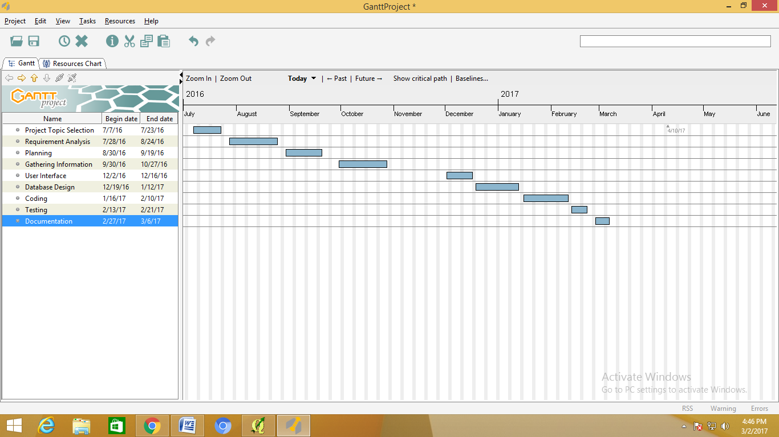

3.2 EVENT TABLE

Sr. No. | Event | Trigger | Source | Activity | Response | Destination
1 | User Login | Enter username and Password | Student/  Admin | Authentication | Form  /Pages /Error Message | Home  /Log IN
2 | View news | Click news bar | Student | Display | Page  /Error message | News  Display
3 | Browse Projects | Click Projects  Menu | Users | Display Projects | Page | Projects List Page
4 | Browse  Ebooks | Click Ebooks  Menu | Users | Display Ebooks | Page | Ebooks List page
5 | Upload Project | Select File from System | Admin | Modification/Upload | Form/Error Message | Projects List Page
6 | Download Project | Click Project Download | Users | Download | Output stream | Projects List Page
7 | Download Ebooks | Click Ebooks Download | Users | Download | Output stream | Ebooks List Page
8 | Upload Ebook | Select File from System | Admin | Modification/Upload | Form/Error Message | Ebooks List Page

3.3 Use Case Diagram
A use case diagram in the Unified Modelling Language (UML) is a type of behavioural diagram defined by and created from a Use-case analysis. Its purpose is to present a graphical overview of the functionality provided by a system in terms of actors, their goals (represented as use cases), and any dependencies between those use cases.
The main purpose of a use case diagram is to show what system functions are performed for which actor. Roles of the actors in the system can be depicted.
Use Case diagrams are formally included in two modelling languages defined by the OMG: the Unified Modelling Language (UML) and the Systems Modelling Language (SysML).

Diagram building blocks: Interaction among actors is not shown on the use case diagram. Alternatively, interaction among actors can be part of the assumptions used in the use case.

Use cases: A use case describes a sequence of actions that provide something of measurable value to an actor and is drawn as a horizontal ellipse.

Elements of use case

Actors: An actor portrays any entity (or entities) that perform certain roles in a given system. The different roles the actor represents are actual business roles of the users in a system.

While modelling, it is up to you to consider what actors make an impact on the Functionality that you want to model. If the entity does not affect a certain piece of functionality that you are modelling, it makes no sense to represent it as an actor. An actor is shown as a stick figure in use case diagram depicted “outside” the system boundary.

A use case is shown as an ellipse in a use case diagram:
Discovering implicit use case is possible only with a thorough understanding of all business processes of the system through discussions with potential users of the system and relevant domain knowledge. For example, consider processes in Medical clinic system such as “Manage patient's personal records” and “Manage patient's medical information” may not be mentioned in requirements documents.

System Boundary:

A system boundary defines the scope of what a system will be a system cannot have infinite functionality. Thus, a use case needs to have definite limits. A system boundary of a use case diagram defines the limits of the system. The system boundary is shown as a rectangle spanning all use cases in the system.
Associations: This is used to show the participation of actor in a use case i.e. an actor instance communicates with a process instance.
Relationships in use case:
Use cases share different kinds of relationships. Relationship between two cases is basically a dependency between two use cases.
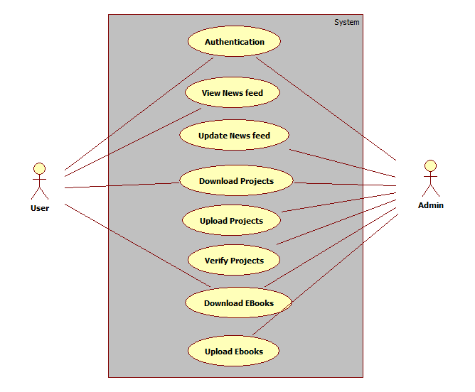
3.4 Sequence Diagram / Collaboration Diagram
UML Sequence Diagrams are used to represent or model the flow of messages, events and actions between the objects or components of a system.Time is represented in the vertical direction showing the sequence of iterations of the header elements, which are displayed horizontally at the top of the diagram.
A Sequence diagram is an interaction diagram that shows how objects operate with one another and in what order. It is a construct of a message sequence chart.A sequence diagram shows object interactions arranged in time sequence. It depicts the objects and classes involved in the scenario and the sequence of messages exchanged between the objects needed to carry out the functionality of the scenario.Sequence diagrams are typically associated with use case realizations in the Logical View of the system under development. Sequence diagrams are sometimes called event diagrams or event scenarios.
A sequence diagram shows, as parallel vertical lines (lifelines), different processes or objects that live simultaneously, and, as horizontal arrows, the messages exchanged between them, in the order in which they occur. This allows the specification of simple runtime scenarios in a graphical manner.
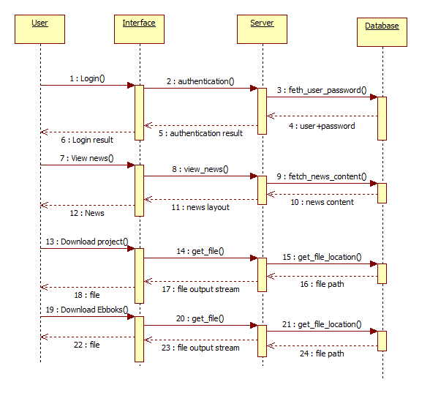
3.5 Activity Diagram

Activity diagrams, which are related to program flow plans (flowcharts), are used to illustrate activities. In the external view, we use activity diagrams for the description of those business processes that describe the functionality of the business system.

Contrary to use case diagrams, in activity diagrams it is obvious whether actors can perform business use cases together or independently from one another.

Activity diagrams allow you to think functionally. Activity diagrams can be developed in various degrees of detail. They can be refined step by step. In the external view, activity diagrams, just like use case diagrams, exclusively represent business processes and activities from the outside perspective. Refining diagrams does not mean describing process details that are performed within the business system, which often leads to an unnoticed shift to the internal view

Action
An action is an individual step within an activity, for example, a calculation step that is not deconstructed any further. That does not necessarily mean that the action cannot be subdivided in the real world, but in this diagram will not be refined any further:
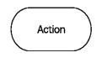

Edge (Control Flow)

Edges, represented by arrows, connect the individual components of activity diagrams and illustrate the control flow of the activity:

Within the control flow an incoming arrow starts a single step of an activity; after the step is completed the flow continues along the outgoing arrow. A name can be attached to an edge (close to the arrow).

Decision Node

The diamond below represents a conditional branch point or decision node. A decision node has one input and two or more outputs:
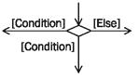

Initial Node

The initial node is the starting point of an activity. An activity can have more than one initial node; in this case several flows start at the beginning of an activity:


It is also possible that an activity has no initial node, but is initiated by an event (action: accepting an event).

Activity Final Node

The activity final node indicates that an activity is completed. An activity diagram can have more than one exit in the form of activity final nodes:


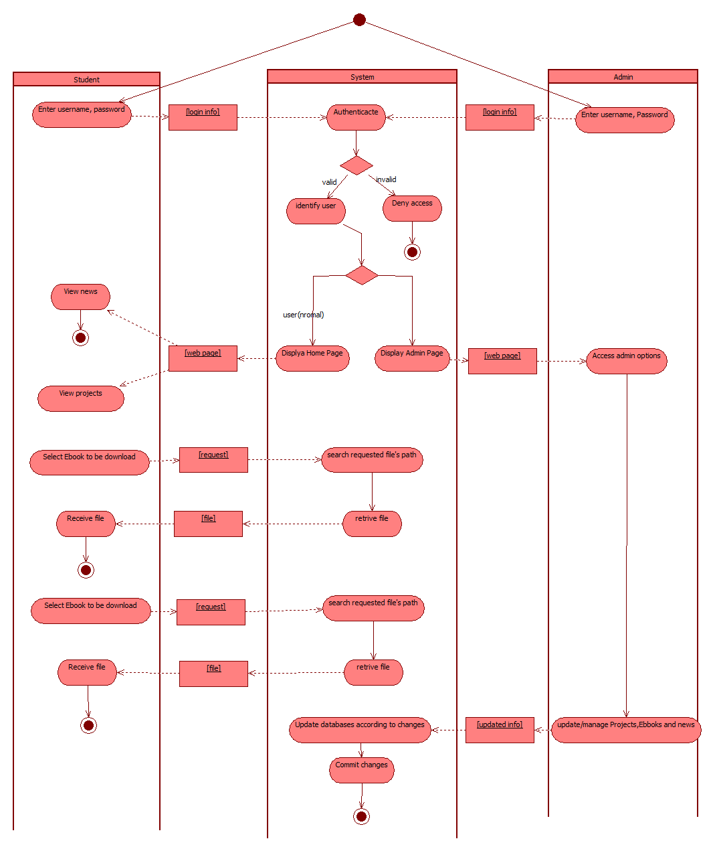
  - Class Diagram

In software engineering, a class diagram in the Unified Modelling Language (UML) is a type of static structure diagram that describes the structure of a system by showing the system's classes, their attributes, operations (or) methods and the relationships between the classes.

  - The class diagram is the main building block in object oriented modelling. It is used both for general conceptual modelling of the systematic of the application, and for detailed modelling translating the models into programming code.

  - The classes in a class diagram represent both the main objects and or interactions in the application and the objects to be programmed. In the class diagram these classes are represented with boxes which contain three parts:

    - The upper part holds the name of the class

    - The middle part contains the attributes of the class

    - The bottom part gives the methods or operations the class can take or undertake.

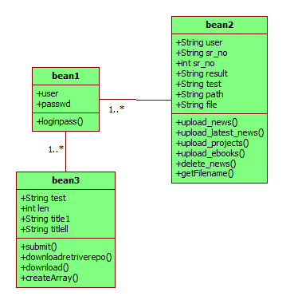
  - State Diagram
A state diagram is a type of diagram used in computer science and related fields to describe the behaviour of systems.
State diagrams require that the system described is composed of a finite number of states; sometimes, this is indeed the case, while at other times this is a reasonable abstraction.
Many forms of state diagrams exist, which differ slightly and have different semantics.

The symbols used in state diagram are as follows:
Initial State: This shows the starting point of first activity of the flow denoted by a solid circle.

State: State defines current condition of an event or activity. State diagram is often used to describe state changes triggered by events.

Transition: Transition takes operation from one state to another and represents the response to a particular event. A single transition comes out of each state or activity, connecting it to the next state or activity.

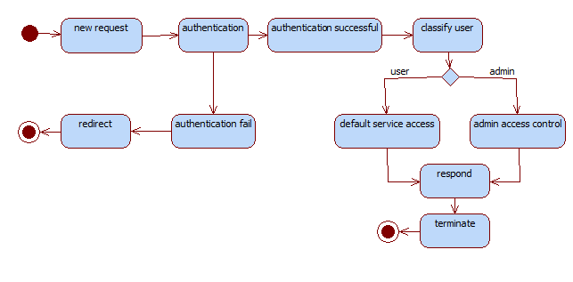
  - Menu Tree

A Tree Diagram is a chart that begins with one central item and then branches into more and keeps branching until the line of inquiry begun with the central item is exhausted. The tree diagram, with its branching steps, motivates you to move from the general to the specific in a systematic way.

It is used to determine the probability of getting specific results where the possibilities are nested.

A menu tree diagram is a way of representing the hierarchical nature of a structure in a graphical form.

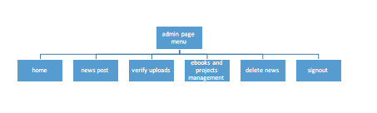
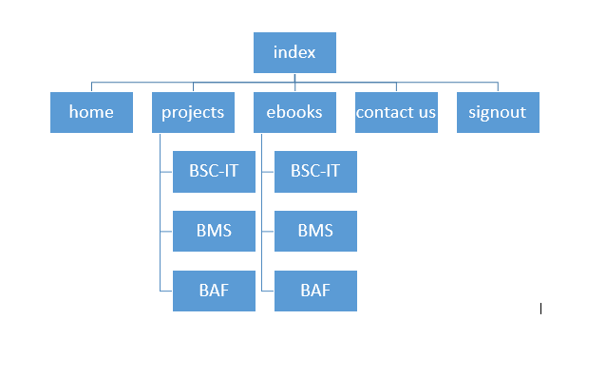

4.SYSTEM DESIGN

4.1 Module Description and architecture design

The architecture of the entire model is designed considering a campus with certain hardware and software specifications. The architecture will be needing a local server, Wi-Fi enabled campus and handheld devices for accessing the data. The intended audiences will be assigned certain rights and privileges to the different levels of users including students, faculty member’s admin and super admin roles.

- College local server

The functioning of the local digital repository is via static IP eg https://182.234.142.60:8080/typrojectf which will belong to the college server. This server will be the main server consisting of web server and its services running on it. Additionally, a Cache memory and a storage purpose a hard disk with the relevant capacity can be used. SSD (Solid State Drives) is been suggested in the paper which will act as a cache for the entire architecture and for storage purpose, the traditional hard drives will be used.
The server will have its motherboard as the one present in the usual PC. The capacity or the requirement of the server can be enhanced depending upon the requirement and the number of users in the college. Linux operating system with its preinstalled drivers and hardware will operate the entire architecture for running the system. Apache or glassfish server can be used to deal with web server request made by the client side.
This whole system will be installed in college itself so all the security implementation is needed inside the college server itself.

MYSQL or oracle Database will be used on server side for data storage and manipulation purpose. The website will be code in the JavaScript, JSF based on the MVC architecture to maintain the integrity of the repository so to keep the view, business logic and control separate. Since the server is running locally inside the college there won’t be any bandwidth problem cause if the college uses an internet connection to provide these facilities it is expensive and also there is always bandwidth and speed limitation issues.

- Wi-Fi enabled campus

In order to provide repository services and to run the system, wifi connection is needed. Since the college is going to have the servers and in order to provide these services locally the college needs to be Wi-Fi enabled. The server will run locally on the wifi connection. The college needs to implant the high speed enabled Wi-Fi capable of 1 gbps up and 1 gbps down in the college in order to provide maximum number of connections pre-area.
- Intended Audiences

The guidance and recommendations included here are primarily intended storing details related to libraries, colleges, various student’s committee groups like (student council), coder’s committee, and scholarly publishers and are specifically aimed at college students, teachers and non-teaching staff for easy accessibility and availability.
The rights of user’s will totally depend on the login valid authentication provided by the college to them eg. Committee heads have the rights to edit and post content on the repository newsfeed. Similarly, the repository admins might have the capability to check on the post and to see what items must be kept or removed from the digital repository.

- MVC architecture

JSF technology is a framework for developing, building server side User Interface Components. These components can be used in a web application. Data consistency and data integrity could be achieved more smoothly using the MVC (Model View Control) JSF Architecture. This architecture consist of three parts : model, view and control. In the major components “model” the business logic is coded.

It maintains the layer of data function that basically acts upon the databases. It also keeps the “view” and “control” separate. The view is the actual content upon which the user interacts and the controller acts as an architecture handler. Controlled decides when the data must be updated on the database or when the next view must be showed to the user upon his interaction.

4.2 Architectural Diagram

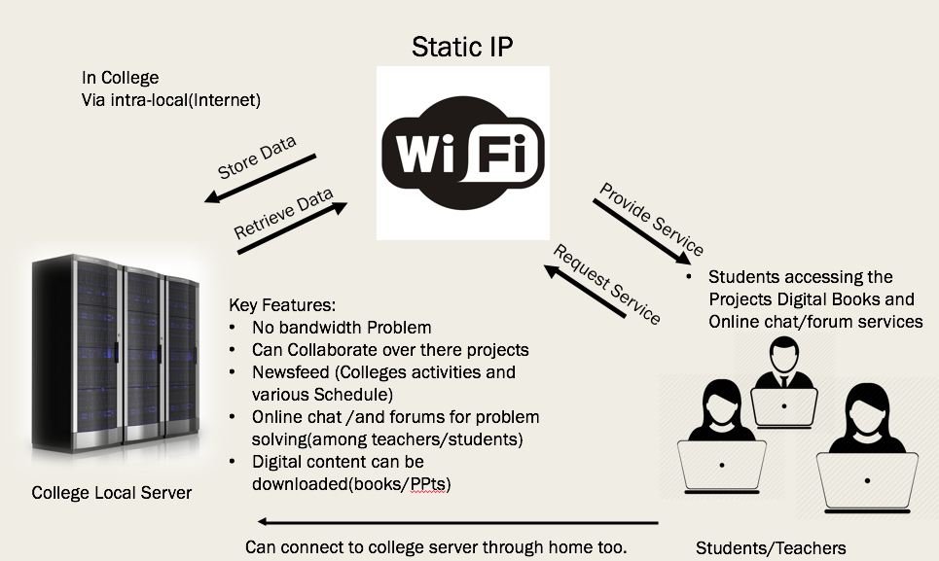

4.3 Program List

All the programs are divided into different modules. Each module has related programs (web pages) that complement each other to achieve that module‟s functionality. The modules and the programs inside them are:

Program Name | Description
404.xhtml | Error reporting page
Contact.xhtml | About us and contact detail
News_delete.xhtml | To delete news from news feed
News_posting.xhtml | To post news in the news feed and upload the projects
Project_ebook_upload.xhtml | To upload the ebooks
Bscit repo.xhtml | To download the repository projects
Login.xhtml | To login into the repository
Single_page.xhtml | To merge the news content with description and display it
Index.xhtml | Home page where news content is displayed
Bean1.java,bean2.java,bean3.java | Contents various functions and class to interact with the database

4.4 Table List

Table | Descrpition
newsfeed_admin | Newsfeed content including Title, description,Image file location etc.
checkuser | Contains usernames nad passwords
bscrepo | Contains project files related contents like file location and id
bscebook | Contains ebooks files related contents like file location and id

1.newsfeed_admin
Field | Type | Null | Key | Defaul | Extra
news | varchar(100) | YES |  | NULL
location | varchar(100) | YES |  | NULL
title | varchar(100) | YES |  | NULL
id | int(11) | ON | PRI | NULL | Auto_increment

2.checkuser (for authentication)
Field | Type | Null | Key | Defaul
usercheck | varchar(30) | YES | PRI | NULL
Passcheck | varchar(20) | YES |  | NULL

3.bscrepo (for project file storage)
Field | Type | Null | Key | Defaul | Extra
Filename | varchar(1000) | YES |  | NULL
Loc | varchar(2000) | YES |  | NULL
id | int(11) | ON | PRI | NULL | Auto_increment

4.bscebook (for ebooks file storage)
Field | Type | Null | Key | Defaul | Extra
Filename | varchar(1000) | YES |  | NULL
Loc | varchar(2000) | YES |  | NULL
id | int(11) | ON | PRI | NULL | Auto_increment

5. Data entry form

Login form

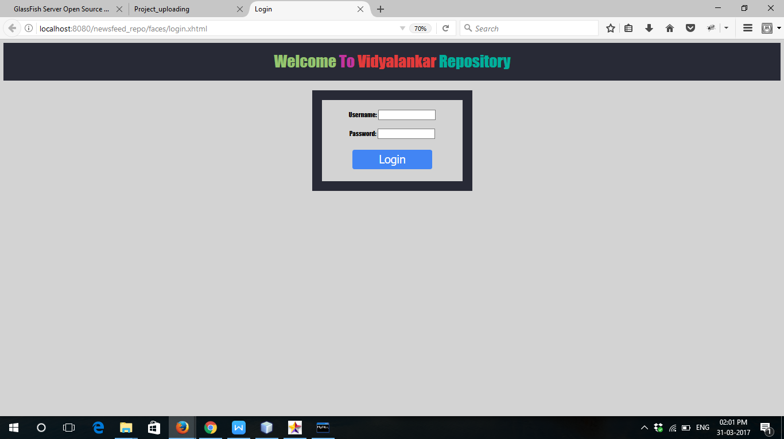

Contact us

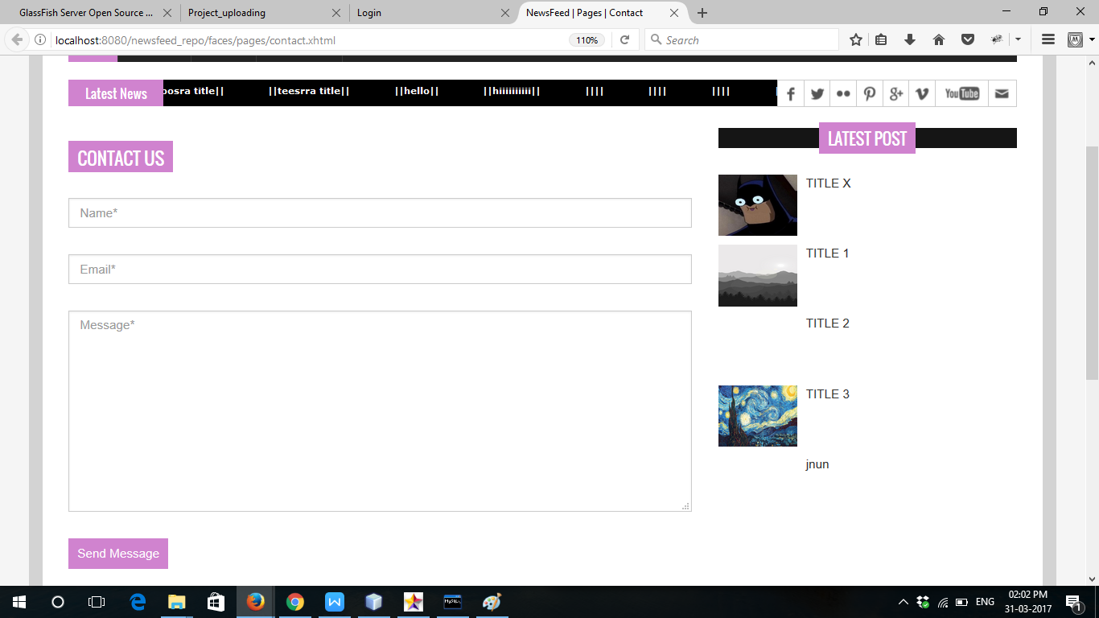

News Delete

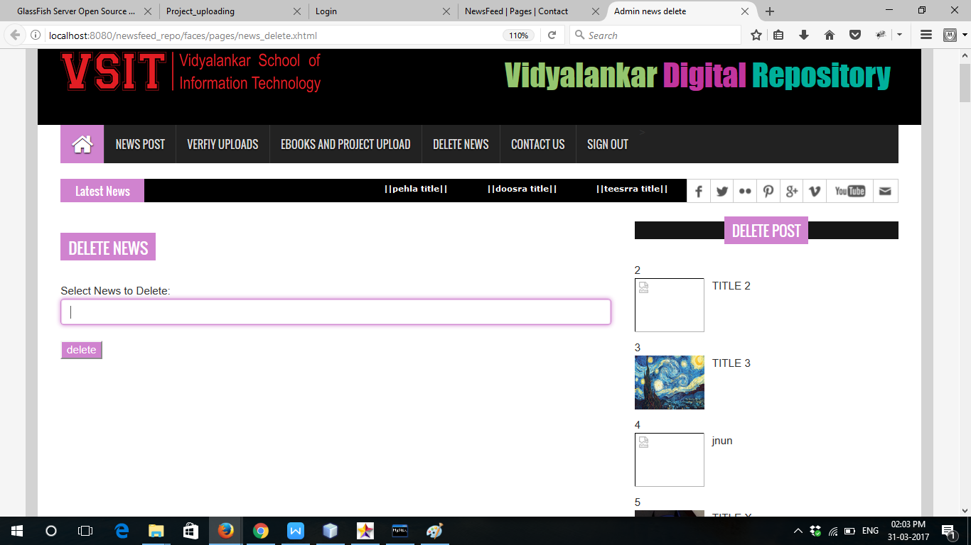

Ebook Upload

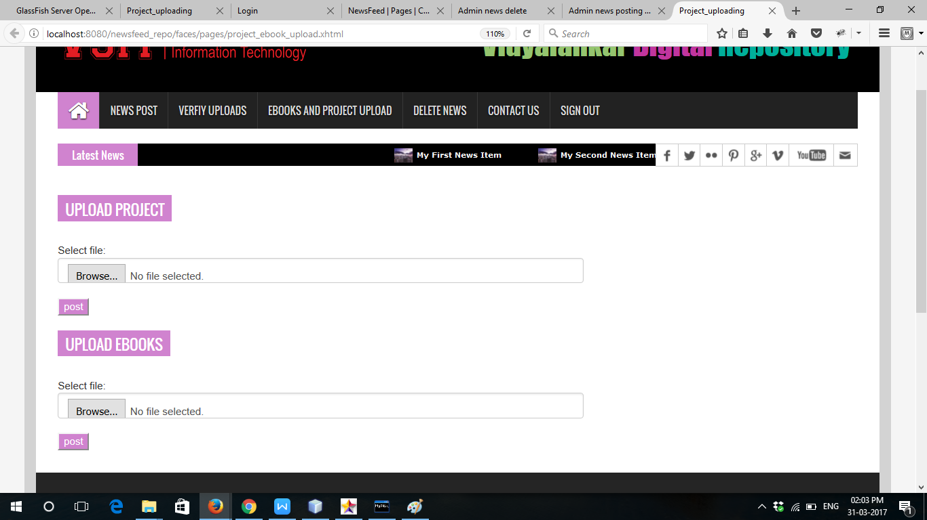

News Posting

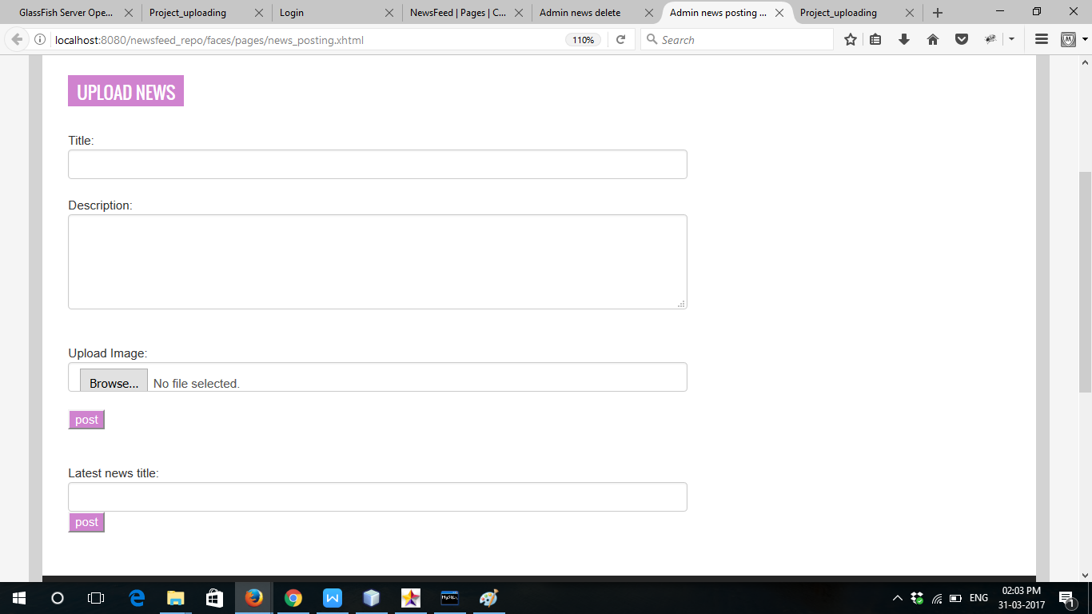

6. SYSTEM TESTING AND CONCLUSION

6.1 System Testing
Testing is the process of examining a product to determine what defects it contains to conduct a test, programmers must have already constructed software and there must be well-defined standard for what constitute a defect. The developers can test products by reviewing their constructions and compositions or by exercising their functions and examining the results.

An information system is an integrated collection of software components.
Components can be tested individually or in groups or entire system can be tested as a whole. Testing components individually or in groups is called unit testing.
Testing components in group is called integrated testing. Testing entire system is called system testing.

The three types of testing are correlated to specific phase of SDLC. A system text examines the behavior of entire system with respect to technical and user. These requirements are determined during analysis phase of SDLC. During high level design, the division of the system into high level components and structural design of those components are determined. Integration testing tests the behavior of variable group of software components. Unit testing test each individual software components in isolation.

Because of each testing level is related to specific phase of SDLC, testing activities can be spread out through the life cycle. Planning for each type testing can occur with its related SDLC phase. And development of specific test can occur once the planning for each type testing can occur with its reached SDLC phase, and development of specific test can occur once the planning is complete. Test can’t be conducted until relevant portion of the system have been constructed.

Unit Testing:

This is a process of testing individual code modules before they integrate with other modules. Unit testing being tested may be a function, sub routine, procedure, or method. Unit testing may be relatively small groups of inter related modules that are always executes as group. The goal of unit testing is to identify and fix as many errors as possible before modules and expensive to locate and fix when many modules are combined.

Integrated Testing:

An integration test tests the behavior of group modules. The purpose of an integration test is to identify errors that were not or could not be detected by unit testing individual modules or methods.

Such error may result from number of problem including
Interface Compatibility
Parameter Values
Runtime Exception
Unexpected State Interaction

System Testing:

After integration, the whole program will again be tested. Case studies will again be applied with integrated software.

Methodology used for testing:

The testing methodology implemented for testing of the project is Black Box testing.

In the black box testing, the internal logic of the system under testing is not considered and the test cases are decided form the specification or the requirements. It is often called functional testing.

It aims to test functionality according to the requirements. Equivalence class portioning, boundary value analysis, and because effecting graphing are examples of methods for selecting test cases for black box testing. State-based testing is another approach in which the system is modeled as a state machine and then this model is used to select test cases using some transaction or path based coverage criteria, state-based testing can also be viewed as grey-box testing in that it often requires more information than just the requirements.

The testing methodology implemented for testing of the project is the black box testing. Refer the above paragraph for explanation.

Test Cases:

The forms were tested for their functionality and error messages displayed wherever the input does not meet the required requirements.

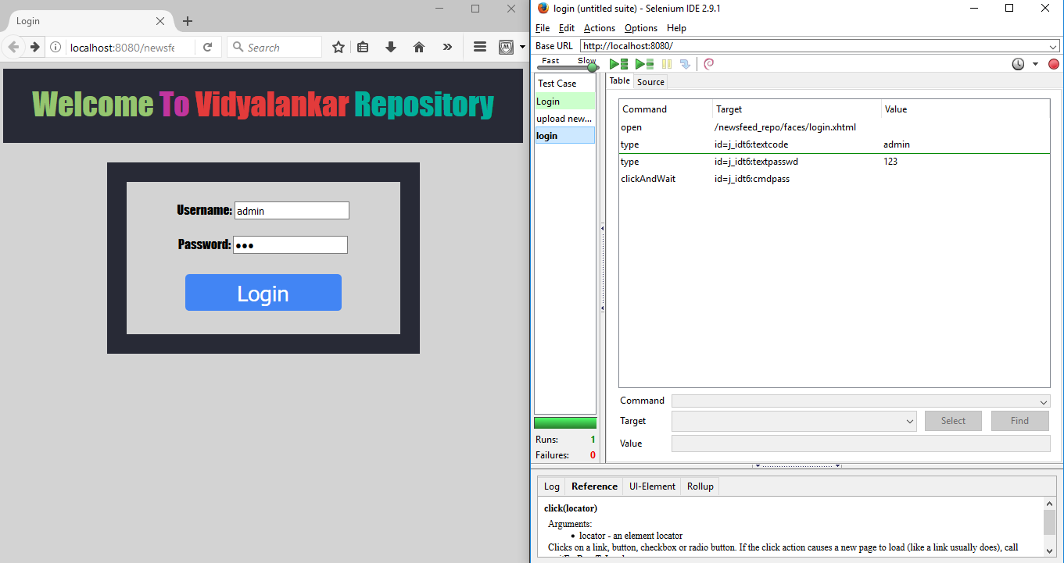
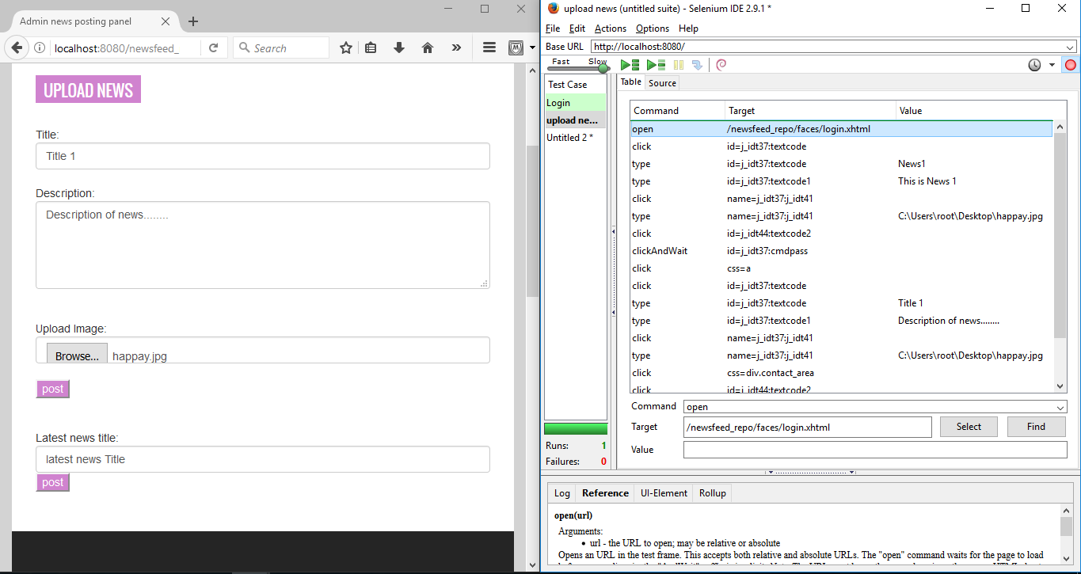

  - Conclusion

This system is mainly designed to reduce the manual work of updating and tracking the records. It is highly efficient and easy to use.

7. Source Code
Index.xhtml

<?xml version='1.0' encoding='UTF-8' ?>
<!DOCTYPE html PUBLIC "-//W3C//DTD XHTML 1.0 Transitional//EN" "http://www.w3.org/TR/xhtml1/DTD/xhtml1-transitional.dtd">
<html xmlns="http://www.w3.org/1999/xhtml"
xmlns:h="http://java.sun.com/jsf/html"
xmlns:c="http://xmlns.jcp.org/jsp/jstl/core">
<head>
<title>NewsFeed</title>
<script type="text/javascript">
function myFunction() {
window.onload=#{b3.submit()};

};
</script>
<meta charset="utf-8"/>
<meta http-equiv="X-UA-Compatible" content="IE=edge"/>
<meta name="viewport" content="width=device-width, initial-scale=1"/>
<link rel="stylesheet" type="text/css" href="assets/css/bootstrap.min.css"/>
<link rel="stylesheet" type="text/css" href="assets/css/font-awesome.min.css"/>
<link rel="stylesheet" type="text/css" href="assets/css/animate.css"/>
<link rel="stylesheet" type="text/css" href="assets/css/font.css"/>
<link rel="stylesheet" type="text/css" href="assets/css/li-scroller.css"/>
<link rel="stylesheet" type="text/css" href="assets/css/slick.css"/>
<link rel="stylesheet" type="text/css" href="assets/css/jquery.fancybox.css"/>
<link rel="stylesheet" type="text/css" href="assets/css/theme.css"/>
<link rel="stylesheet" type="text/css" href="assets/css/style.css"/>
<!--[if lt IE 9]>
<script src="assets/js/html5shiv.min.js"></script>
<script src="assets/js/respond.min.js"></script>
<![endif]-->
</head>
<body>
<div id="preloader">
<div id="status">&nbsp;</div>
</div>

<a class="scrollToTop" href="#"><i class="fa fa-angle-up"></i></a>
<div class="container" style=" background-color: lightgrey;">
<header id="header">
<div class="row" >

<div class="col-lg-12 col-md-12 col-sm-12">
<div class="header_bottom" style=" background-color: black;">
<div class="logo_area" ><a href="index.html" class="logo"><img src="images/VSIT H logo.png" alt=""/></a></div>
<div class="add_banner"> <div class="home" align="right" style="font-size: 40px;padding:12px 10px; font-family: Impact;"> <div class="mid animated zoomIn" ><font color="#95c56f">Vidyalankar</font><font color="c1359e"> Digital</font>
<font color="00af9b"> Repository</font>
</div>
</div></div>
</div>
</div>
</div>
</header>
<section id="navArea">
<nav class="navbar navbar-inverse" role="navigation">
<div class="navbar-header">
<button type="button" class="navbar-toggle collapsed" data-toggle="collapse" data-target="#navbar" aria-expanded="false" aria-controls="navbar"> <span class="sr-only">Toggle navigation</span> <span class="icon-bar"></span> <span class="icon-bar"></span> <span class="icon-bar"></span> </button>
</div>
<div id="navbar" class="navbar-collapse collapse">
<ul class="nav navbar-nav main_nav">
<li class="active"><a href="index.xhtml"><span class="fa fa-home desktop-home"></span><span class="mobile-show">Home</span></a></li>

<li class="dropdown"> <a href="#" class="dropdown-toggle" data-toggle="dropdown" role="button" aria-expanded="false">Projects</a>
<ul class="dropdown-menu" role="menu">
<li><a href="pages/repo bscit.xhtml">BSc-IT</a></li>
<li><a href="#">BMS</a></li>
<li><a href="#">BAF</a></li>

</ul>
</li>
<li><a href="#">Ebooks</a></li>

<li><a href="pages/contact.html">Contact Us</a></li>

<li><a href="login.xhtml" >Sign Out</a></li>
</ul>
</div>
</nav>
</section>

<section id="newsSection">
<div class="row">
<div class="col-lg-12 col-md-12">
<div class="latest_newsarea"> <span>Latest News</span>
<ul id="ticker01" class="news_sticker">

<c:forEach var="i" begin="0" end="15">
<li ><a >||<h:outputText value="#{b3.titlell[i]}"/>||</a></li>

</c:forEach>

</ul>
<div class="social_area">
<ul class="social_nav">
<li class="facebook"><a href="#"></a></li>
<li class="twitter"><a href="#"></a></li>
<li class="flickr"><a href="#"></a></li>
<li class="pinterest"><a href="#"></a></li>
<li class="googleplus"><a href="#"></a></li>
<li class="vimeo"><a href="#"></a></li>
<li class="youtube"><a href="#"></a></li>
<li class="mail"><a href="#"></a></li>
</ul>
</div>
</div>
</div>
</div>
</section>
<section id="sliderSection">
<div class="row">
<div class="col-lg-8 col-md-8 col-sm-8">
<div class="slick_slider">
<!-- <c:forEach var="i" begin="0" end="4">-->
<div class="single_iteam"> <a href="pages/single_page.xhtml" > <h:graphicImage value="${b3.address[0]}"/></a>
<div class="slider_article">
<h2><a class="slider_tittle" href="pages/single_page.xhtml"><h:outputText value="#{b3.title1[0]}"/></a></h2>
<p><h:outputText value="#{b3.test[0]}"/></p>
</div>
</div>

<div class="single_iteam" > <a href="pages/single_page1.xhtml" > <h:graphicImage value="${b3.address[1]}" /></a>
<div class="slider_article">
<h2><a class="slider_tittle" href="pages/single_page1.xhtml"><h:outputText value="#{b3.title1[1]}"/></a></h2>
<p><h:outputText value="#{b3.test[1]}"/></p>
</div>
</div>
<div class="single_iteam" > <a href="pages/single_page2.xhtml"> <h:graphicImage value="${b3.address[2]}"/></a>
<div class="slider_article">
<h2><a class="slider_tittle" href="pages/single_page2.xhtml"><h:outputText value="#{b3.title1[2]}"/></a></h2>
<p><h:outputText value="#{b3.test[2]}"/></p>
</div>
</div>

<div class="single_iteam" > <a href="pages/single_page3.xhtml" > <h:graphicImage value="${b3.address[3]}"/></a>
<div class="slider_article">
<h2><a class="slider_tittle" href="pages/single_page3.xhtml"><h:outputText value="#{b3.title1[3]}"/></a></h2>
<p><h:outputText value="#{b3.test[3]}"/></p>
</div>
</div>
<div class="single_iteam" > <a href="pages/single_page4.xhtml"> <h:graphicImage value="${b3.address[4]}"/></a>
<div class="slider_article">
<h2><a class="slider_tittle" href="pages/single_page4.xhtml"><h:outputText value="#{b3.title1[4]}"/></a></h2>
<p><h:outputText value="#{b3.test[4]}"/></p>
</div>
</div>

</div>
</div>

<div class="col-lg-4 col-md-4 col-sm-4">
<div class="latest_post">
<h2><span>Latest post</span></h2>
<div class="latest_post_container">
<div id="prev-button"><i class="fa fa-chevron-up"></i></div>
<ul class="latest_postnav">
<li>
<div class="media"> <a class="media-left"><h:graphicImage value="${b3.address[0]}"/> </a>
<div class="media-body"> <a class="catg_title"><h:outputText value="#{b3.title1[0]}"/> </a> </div>
</div>
</li>
<li>
<div class="media"> <a class="media-left"><h:graphicImage value="${b3.address[1]}"/> </a>
<div class="media-body"> <a class="catg_title"><h:outputText value="#{b3.title1[1]}"/> </a> </div>
</div>
</li>
<li>
<div class="media"> <a class="media-left"><h:graphicImage value="${b3.address[2]}"/> </a>
<div class="media-body"> <a class="catg_title"><h:outputText value="#{b3.title1[2]}"/> </a> </div>
</div>
</li>
<li>
<div class="media"> <a class="media-left"><h:graphicImage value="${b3.address[3]}"/> </a>
<div class="media-body"> <a class="catg_title"><h:outputText value="#{b3.title1[3]}"/> </a> </div>
</div>
</li>
<li>
<div class="media"> <a class="media-left"><h:graphicImage value="${b3.address[4]}"/> </a>
<div class="media-body"> <a class="catg_title"><h:outputText value="#{b3.title1[4]}"/> </a> </div>
</div>
</li>

</ul>
<div id="next-button"><i class="fa fa-chevron-down"></i></div>
</div>
</div>
</div>
</div>
</section>
<section id="contentSection">
<div class="row">
<div class="col-lg-8 col-md-8 col-sm-8">
<div class="left_content">

</div>
</div>

</div>
</section>
<footer id="footer">
<div class="footer_top">
<div class="row">
<div class="col-lg-4 col-md-4 col-sm-4">
<div class="footer_widget wow fadeInLeftBig">

<h2><br/></h2>
</div>
</div>

<div class="col-lg-4 col-md-4 col-sm-4">
<div class="footer_widget wow fadeInRightBig">
<h2>Vidyalankar</h2>
<p> this content is under provision of vidyalankar school of information technology.</p>
<address>

</address>
</div>
</div>
<div class="col-lg-4 col-md-4 col-sm-4">
<div class="footer_widget wow fadeInLeftBig">

<h2><br/></h2>
</div>
</div>
</div>
</div>
<div class="footer_bottom">
<p class="copyright"><a href="index.html">© 2016 VSIT Wadala</a></p>
<p class="developer" style="color: white;">Developed By Kunal and Rohit</p>
</div>
</footer>
</div>
<script src="assets/js/jquery.min.js"></script>
<script src="assets/js/wow.min.js"></script>
<script src="assets/js/bootstrap.min.js"></script>
<script src="assets/js/slick.min.js"></script>
<script src="assets/js/jquery.li-scroller.1.0.js"></script>
<script src="assets/js/jquery.newsTicker.min.js"></script>
<script src="assets/js/jquery.fancybox.pack.js"></script>
<script src="assets/js/custom.js"></script>
</body>
</html>

Single_page.xhtml

<?xml version='1.0' encoding='UTF-8' ?>
<!DOCTYPE html PUBLIC "-//W3C//DTD XHTML 1.0 Transitional//EN" "http://www.w3.org/TR/xhtml1/DTD/xhtml1-transitional.dtd">
<html xmlns="http://www.w3.org/1999/xhtml"
xmlns:h="http://java.sun.com/jsf/html"
xmlns:c="http://xmlns.jcp.org/jsp/jstl/core">
<head>
<script type="text/javascript">
function myFunction() {
window.onload=#{b3.submit()};

}

</script>
<title>NewsFeed | Pages | Single Page</title>
<meta charset="utf-8"/>
<meta http-equiv="X-UA-Compatible" content="IE=edge"/>
<meta name="viewport" content="width=device-width, initial-scale=1"/>
<link rel="stylesheet" type="text/css" href="../assets/css/bootstrap.min.css"/>
<link rel="stylesheet" type="text/css" href="../assets/css/font-awesome.min.css"/>
<link rel="stylesheet" type="text/css" href="../assets/css/animate.css"/>
<link rel="stylesheet" type="text/css" href="../assets/css/font.css"/>
<link rel="stylesheet" type="text/css" href="../assets/css/li-scroller.css"/>
<link rel="stylesheet" type="text/css" href="../assets/css/slick.css"/>
<link rel="stylesheet" type="text/css" href="../assets/css/jquery.fancybox.css"/>
<link rel="stylesheet" type="text/css" href="../assets/css/theme.css"/>
<link rel="stylesheet" type="text/css" href="../assets/css/style.css"/>
<!--[if lt IE 9]>
<script src="../assets/js/html5shiv.min.js"></script>
<script src="../assets/js/respond.min.js"></script>
<![endif]-->
</head>
<body>
<!--<div id="preloader">
<div id="status">&nbsp;</div>
</div>-->
<a class="scrollToTop" href="#"><i class="fa fa-angle-up"></i></a>
<div class="container" style=" background-color: lightgrey;">
<header id="header">
<div class="row" >

<div class="col-lg-12 col-md-12 col-sm-12">
<div class="header_bottom" style=" background-color: black;">
<div class="logo_area" ><a href="../index.xhtml" class="logo"><img src="../images/VSIT H logo.png" alt=""/></a></div>
<div class="add_banner"> <div class="home" align="right" style="font-size: 40px;padding:12px 10px; font-family: Impact;"> <div class="mid animated zoomIn" ><font color="#95c56f">Vidyalankar</font><font color="c1359e"> Digital</font>
<font color="00af9b"> Repository</font>
</div>
</div></div>
</div>
</div>
</div>
</header>
<section id="navArea">
<nav class="navbar navbar-inverse" role="navigation">
<div class="navbar-header">
<button type="button" class="navbar-toggle collapsed" data-toggle="collapse" data-target="#navbar" aria-expanded="false" aria-controls="navbar"> <span class="sr-only">Toggle navigation</span> <span class="icon-bar"></span> <span class="icon-bar"></span> <span class="icon-bar"></span> </button>
</div>
<div id="navbar" class="navbar-collapse collapse">
<ul class="nav navbar-nav main_nav">
<li class="active"><a href="../index.xhtml"><span class="fa fa-home desktop-home"></span><span class="mobile-show">Home</span></a></li>

<li class="dropdown"> <a href="#" class="dropdown-toggle" data-toggle="dropdown" role="button" aria-expanded="false">Projects</a>
<ul class="dropdown-menu" role="menu">
<li><a href="repo bscit.xhtml">BSc-IT</a></li>
<li><a href="#">BMS</a></li>
<li><a href="#">BAF</a></li>

</ul>
</li>
<li><a href="#">Ebooks</a></li>

<li><a href="contact.xhtml">Contact Us</a></li>

<li><a href="../login.xhtml" >Sign Out</a></li>
</ul>
</div>
</nav>
</section>
<section id="newsSection">
<div class="row">
<div class="col-lg-12 col-md-12">
<div class="latest_newsarea"> <span>Latest News</span>
<ul id="ticker01" class="news_sticker">

<c:forEach var="i" begin="0" end="15">
<li ><a >||<h:outputText value="#{b3.titlell[i]}"/>||</a></li>

</c:forEach>

</ul>
<div class="social_area">
<ul class="social_nav">
<li class="facebook"><a href="#"></a></li>
<li class="twitter"><a href="#"></a></li>
<li class="flickr"><a href="#"></a></li>
<li class="pinterest"><a href="#"></a></li>
<li class="googleplus"><a href="#"></a></li>
<li class="vimeo"><a href="#"></a></li>
<li class="youtube"><a href="#"></a></li>
<li class="mail"><a href="#"></a></li>
</ul>
</div>
</div>
</div>
</div>
</section>
<section id="contentSection">
<div class="row">
<div class="col-lg-8 col-md-8 col-sm-8">
<div class="left_content">
<div class="single_page">
<ol class="breadcrumb">
<li><a href="../index.html">Home</a></li>
<li><a href="#">Technology</a></li>

</ol>

<h1><h:outputText value="#{b3.title1[0]}"/></h1>
<div class="post_commentbox"> <a href="#"><i class="fa fa-user"></i>Wpfreeware</a> <span><i class="fa fa-calendar"></i>6:49 AM</span> <a href="#"><i class="fa fa-tags"></i>Technology</a> </div>
<div class="single_page_content"> <h:graphicImage class="img-center" value="${b3.address[0]}"/>
<p></p>
<blockquote> <h:outputText value="#{b3.test[0]}"/></blockquote>
</div>
<div class="social_link">
<ul class="sociallink_nav">
<li><a href="#"><i class="fa fa-facebook"></i></a></li>
<li><a href="#"><i class="fa fa-twitter"></i></a></li>
<li><a href="#"><i class="fa fa-google-plus"></i></a></li>
<li><a href="#"><i class="fa fa-linkedin"></i></a></li>
<li><a href="#"><i class="fa fa-pinterest"></i></a></li>
</ul>
</div>
<div class="related_post">
<h2>Related Post <i class="fa fa-thumbs-o-up"></i></h2>
<ul class="spost_nav wow fadeInDown animated">
<li>
<div class="media"> <a class="media-left" href="single_page.html"> <img src="../images/post_img1.jpg" alt=""/> </a>
<div class="media-body"> <a class="catg_title" href="single_page.html"> Aliquam malesuada diam eget turpis varius</a> </div>
</div>
</li>
<li>
<div class="media"> <a class="media-left" href="single_page.html"> <img src="../images/post_img2.jpg" alt=""/> </a>
<div class="media-body"> <a class="catg_title" href="single_page.html"> Aliquam malesuada diam eget turpis varius</a> </div>
</div>
</li>
<li>
<div class="media"> <a class="media-left" href="single_page.html"> <img src="../images/post_img1.jpg" alt=""/> </a>
<div class="media-body"> <a class="catg_title" href="single_page.html"> Aliquam malesuada diam eget turpis varius</a> </div>
</div>
</li>
</ul>
</div>
</div>
</div>
</div>

<div class="col-lg-4 col-md-4 col-sm-4">
<aside class="right_content">
<div class="latest_post">
<h2><span>Latest post</span></h2>
<div class="latest_post_container">
<div id="prev-button"><i class="fa fa-chevron-up"></i></div>
<ul class="latest_postnav">
<li>
<div class="media"> <a class="media-left"><h:graphicImage value="${b3.address[0]}"/> </a>
<div class="media-body"> <a class="catg_title"><h:outputText value="#{b3.title1[0]}"/> </a> </div>
</div>
</li>
<li>
<div class="media"> <a class="media-left"><h:graphicImage value="${b3.address[1]}"/> </a>
<div class="media-body"> <a class="catg_title"><h:outputText value="#{b3.title1[1]}"/> </a> </div>
</div>
</li>
<li>
<div class="media"> <a class="media-left"><h:graphicImage value="${b3.address[2]}"/> </a>
<div class="media-body"> <a class="catg_title"><h:outputText value="#{b3.title1[2]}"/> </a> </div>
</div>
</li>
<li>
<div class="media"> <a class="media-left"><h:graphicImage value="${b3.address[3]}"/> </a>
<div class="media-body"> <a class="catg_title"><h:outputText value="#{b3.title1[3]}"/> </a> </div>
</div>
</li>
<li>
<div class="media"> <a class="media-left"><h:graphicImage value="${b3.address[4]}"/> </a>
<div class="media-body"> <a class="catg_title"><h:outputText value="#{b3.title1[4]}"/> </a> </div>
</div>
</li>

</ul>
<div id="next-button"><i class="fa fa-chevron-down"></i></div>
</div>
</div>
<div class="single_sidebar">
<ul class="nav nav-tabs" role="tablist">
<li role="presentation" class="active"><a href="#category" aria-controls="home" role="tab" data-toggle="tab">Category</a></li>
<li role="presentation"><a href="#video" aria-controls="profile" role="tab" data-toggle="tab">Video</a></li>
<li role="presentation"><a href="#comments" aria-controls="messages" role="tab" data-toggle="tab">Comments</a></li>
</ul>
<div class="tab-content">
<div role="tabpanel" class="tab-pane active" id="category">
<ul>
<li class="cat-item"><a href="#">Management</a></li>
<li class="cat-item"><a href="#">Information Technology</a></li>
<li class="cat-item"><a href="#">Business</a></li>
<li class="cat-item"><a href="#">Technology</a></li>
<li class="cat-item"><a href="#">Games</a></li>

</ul>
</div>
<div role="tabpanel" class="tab-pane" id="video">
<div class="vide_area">
<iframe width="100%" height="250" src="http://www.youtube.com/embed/h5QWbURNEpA?feature=player_detailpage" frameborder="0" ></iframe>
</div>
</div>
<div role="tabpanel" class="tab-pane" id="comments">
<ul class="spost_nav">
<li>
<div class="media wow fadeInDown"> <a href="single_page.html" class="media-left"> <img alt="" src="../images/post_img1.jpg"/> </a>
<div class="media-body"> <a href="single_page.html" class="catg_title"> Aliquam malesuada diam eget turpis varius 1</a> </div>
</div>
</li>
<li>
<div class="media wow fadeInDown"> <a href="single_page.html" class="media-left"> <img alt="" src="../images/post_img2.jpg"/> </a>
<div class="media-body"> <a href="single_page.html" class="catg_title"> Aliquam malesuada diam eget turpis varius 2</a> </div>
</div>
</li>
<li>
<div class="media wow fadeInDown"> <a href="single_page.html" class="media-left"> <img alt="" src="../images/post_img1.jpg"/> </a>
<div class="media-body"> <a href="single_page.html" class="catg_title"> Aliquam malesuada diam eget turpis varius 3</a> </div>
</div>
</li>
<li>
<div class="media wow fadeInDown"> <a href="single_page.html" class="media-left"> <img alt="" src="../images/post_img2.jpg"/> </a>
<div class="media-body"> <a href="single_page.html" class="catg_title"> Aliquam malesuada diam eget turpis varius 4</a> </div>
</div>
</li>
</ul>
</div>
</div>
</div>
<div class="single_sidebar wow fadeInDown">
<h2><span>Sponsor</span></h2>
<a class="sideAdd" href="#"><img src="../images/add_img1.jpg" alt=""/></a> </div>
<div class="single_sidebar wow fadeInDown">
<h2><span>Category Archive</span></h2>
<select class="catgArchive">
<option>Select Category</option>
<option>Life styles</option>
<option>Sports</option>
<option>Technology</option>
<option>Treads</option>
</select>
</div>
<div class="single_sidebar wow fadeInDown">
<h2><span>Links</span></h2>
<ul>
<li><a href="#">Blog</a></li>
<li><a href="#">Rss Feed</a></li>
<li><a href="#">Login</a></li>
<li><a href="#">Life &amp; Style</a></li>
</ul>
</div>
</aside>
</div>
</div>
</section>
<footer id="footer">
<div class="footer_top">
<div class="row">
<div class="col-lg-4 col-md-4 col-sm-4">
<div class="footer_widget wow fadeInLeftBig">

<h2><br/></h2>
</div>
</div>

<div class="col-lg-4 col-md-4 col-sm-4">
<div class="footer_widget wow fadeInRightBig">
<h2>Vidyalankar</h2>
<p> this content is under provision of vidyalankar school of information technology.</p>
<address>

</address>
</div>
</div>
<div class="col-lg-4 col-md-4 col-sm-4">
<div class="footer_widget wow fadeInLeftBig">
<h2><br/></h2>
</div>
</div>
</div>
</div>
<div class="footer_bottom">
<p class="copyright"><a href="index.html">© 2016 VSIT Wadala</a></p>
<p class="developer" style="color: white;">Developed By Kunal and Rohit</p>
</div>
</footer>
</div>
<script src="../assets/js/jquery.min.js"></script>
<script src="../assets/js/wow.min.js"></script>
<script src="../assets/js/bootstrap.min.js"></script>
<script src="../assets/js/slick.min.js"></script>
<script src="../assets/js/jquery.li-scroller.1.0.js"></script>
<script src="../assets/js/jquery.newsTicker.min.js"></script>
<script src="../assets/js/jquery.fancybox.pack.js"></script>
<script src="../assets/js/custom.js"></script>
</body>
</html>

Login.xhtml
<?xml version='1.0' encoding='UTF-8' ?>
<!DOCTYPE html PUBLIC "-//W3C//DTD XHTML 1.0 Transitional//EN" "http://www.w3.org/TR/xhtml1/DTD/xhtml1-transitional.dtd">
<html xmlns="http://www.w3.org/1999/xhtml"
xmlns:h="http://xmlns.jcp.org/jsf/html"
xmlns:c="http://xmlns.jcp.org/jsp/jstl/core"
xmlns:p="http://xmlns.jcp.org/jsf/passthrough"
xmlns:ui="http://xmlns.jcp.org/jsf/facelets">
<h:head>
<title>Login</title>
<link rel="stylesheet" href="animate.css"></link>
<link rel="stylesheet" href="main.css"></link>
<link rel="text/html" href="menubar.htm"></link>
</h:head>
<h:body>
<div class="welcome">
<center><div class="hello animated fadeInDown " >
<font color="#95c56f">Welcome</font><font color="c1359e"> To</font>
<font color="e33b3b"> Vidyalankar</font><font color="00af9b"> Repository</font>
</div> </center></div>
<center>
<div class="loginform animated bounceInDown">
<h:form>
<div class="box">
Username:
<h:inputText id="textcode" value="#{b1.user}"/>
<br/>
<br/>
Password:
<h:inputSecret id="textpasswd" value="#{b1.passwd}"/>
<br/><br/>

<h:commandButton class="button" id="cmdpass" value="Login" action="#{b1.loginpass()}" />

</div>

</h:form>

</div>
</center>

</h:body>
</html>

New_delete.xhtml
<?xml version="1.0" encoding="UTF-8"?>
<!--
To change this license header, choose License Headers in Project Properties.
To change this template file, choose Tools | Templates
and open the template in the editor.
-->
<!DOCTYPE html>
<html xmlns="http://www.w3.org/1999/xhtml"
xmlns:h="http://java.sun.com/jsf/html"
xmlns:c="http://xmlns.jcp.org/jsp/jstl/core">
<head>
<title>Admin news delete</title>
<meta charset="utf-8"/>
<meta http-equiv="X-UA-Compatible" content="IE=edge"/>
<!--meta name="viewport" content="width=device-width, initial-scale=1"/-->
<link rel="stylesheet" type="text/css" href="../assets/css/bootstrap.min.css"/>
<link rel="stylesheet" type="text/css" href="../assets/css/font-awesome.min.css"/>
<link rel="stylesheet" type="text/css" href="../assets/css/animate.css"/>
<link rel="stylesheet" type="text/css" href="../assets/css/font.css"/>
<link rel="stylesheet" type="text/css" href="../assets/css/li-scroller.css"/>
<link rel="stylesheet" type="text/css" href="../assets/css/slick.css"/>
<link rel="stylesheet" type="text/css" href="../assets/css/jquery.fancybox.css"/>
<link rel="stylesheet" type="text/css" href="../assets/css/theme.css"/>
<link rel="stylesheet" type="text/css" href="../assets/css/style.css"/>

<meta name="viewport" content="width=device-width, initial-scale=1.0"/>
<script type="text/javascript">
function myFunction() {
window.onload=#{b3.submit()};

};

</script>
</head>
<body>

<!--<div id="preloader">
<div id="status"></div>
</div>-->
<a class="scrollToTop" href="#"><i class="fa fa-angle-up"></i></a>
<div class="container" style=" background-color: lightgrey;">
<header id="header">
<div class="row" >

<div class="col-lg-12 col-md-12 col-sm-12">
<div class="header_bottom" style=" background-color: black;">
<div class="logo_area" ><a href="index.html" class="logo"><img src="../images/VSIT H logo.png" alt=""/></a></div>
<div class="add_banner"> <div class="home" align="right" style="font-size: 40px;padding:12px 10px; font-family: Impact;"> <div class="mid animated zoomIn" ><font color="#95c56f">Vidyalankar</font><font color="c1359e"> Digital</font>
<font color="00af9b"> Repository</font>
</div>
</div></div>
</div>
</div>
</div>
</header>
<section id="navArea">
<nav class="navbar navbar-inverse" role="navigation">
<div class="navbar-header">
<!--h:commandButton type="button" class="navbar-toggle collapsed" data-toggle="collapse" data-target="#navbar" aria-expanded="false" aria-controls="navbar"/> <span class="sr-only">Toggle navigation</span> <span class="icon-bar"></span> <span class="icon-bar"></span> <span class="icon-bar"></span> </button-->
</div>
<div id="navbar" class="navbar-collapse collapse">
<ul class="nav navbar-nav main_nav">
<li class="active"><a href="../index.xhtml"><span class="fa fa-home desktop-home"></span><span class="mobile-show">Home</span></a></li>
<li><a href="news_posting.xhtml">News Post</a></li>
<li><a href="#">Verfiy Uploads</a></li>
<li><a href="project_ebook_upload.xhtml">Ebooks and Project upload</a></li>>
<li><a href="news_delete.xhtml">Delete News</a></li>
<li><a href="contact.xhtml">Contact Us</a></li>
<li><a href="../login.xhtml" >Sign Out</a></li>

</ul>
</div>
</nav>
</section>
<section id="newsSection">
<div class="row">
<div class="col-lg-12 col-md-12">
<div class="latest_newsarea"> <span>Latest News</span>
<ul id="ticker01" class="news_sticker">

<c:forEach var="i" begin="0" end="10">
<li ><a >||<h:outputText value="#{b3.titlell[i]}"/>||</a></li>

</c:forEach>

</ul>
<div class="social_area">
<ul class="social_nav">
<li class="facebook"><a href="#"></a></li>
<li class="twitter"><a href="#"></a></li>
<li class="flickr"><a href="#"></a></li>
<li class="pinterest"><a href="#"></a></li>
<li class="googleplus"><a href="#"></a></li>
<li class="vimeo"><a href="#"></a></li>
<li class="youtube"><a href="#"></a></li>
<li class="mail"><a href="#"></a></li>
</ul>
</div>
</div>
</div>
</div>
</section>
<section id="contentSection">
<div class="row">
<div class="col-lg-8 col-md-8 col-sm-8">
<div class="left_content">
<div class="contact_area">
<h2>Delete News</h2>

<h:form enctype="multipart/form-data">

Select News to Delete: <h:inputText required="true" class="form-control" id="textcode" size="5" value="#{b2.sr_no}"/>
<br/>

<h:commandButton class="btn-theme" id="cmdpass" value="delete" action="#{b2.delete_news()}" />
<br/><br/>

</h:form>
</div>
</div>
</div>
<div class="col-lg-4 col-md-4 col-sm-4">
<div class="latest_post">
<h2><span>Delete post</span></h2>
<div class="latest_post_container">
<div id="prev-button"><i class="fa fa-chevron-up"></i></div>
<ul class="latest_postnav">
<c:forEach var="i" begin="0" end="60">
<li>
<h:outputText value="#{b3.id[i]}"/>
<div class="media"> <a href="pages/single_page.xhtml" class="media-left"><h:graphicImage value="${b3.address[i]}"/></a>
<div class="media-body"> <a href="pages/single_page.html" class="catg_title"><h:outputText value="#{b3.title1[i]}"/> </a> </div>
</div>
</li>
</c:forEach>

</ul>
<div id="next-button"><i class="fa fa-chevron-down"></i></div>
</div>
</div>
</div>
</div>
</section>
<footer id="footer">
<div class="footer_top">
<div class="row">
<div class="col-lg-4 col-md-4 col-sm-4">
<div class="footer_widget wow fadeInLeftBig">

<h2><br/></h2>
</div>
</div>

<div class="col-lg-4 col-md-4 col-sm-4">
<div class="footer_widget wow fadeInRightBig">
<h2>Vidyalankar</h2>
<p> this content is under provision of vidyalankar school of information technology.</p>
<address>

</address>
</div>
</div>
<div class="col-lg-4 col-md-4 col-sm-4">
<div class="footer_widget wow fadeInLeftBig">

<h2><br/></h2>
</div>
</div>
</div>
</div>
<div class="footer_bottom">
<p class="copyright"><a href="index.html">© 2016 VSIT Wadala</a></p>
<p class="developer" style="color: white;">Developed By Kunal and Rohit</p>
</div>
</footer>
</div>
<script src="../assets/js/jquery.min.js"></script>
<script src="../assets/js/wow.min.js"></script>
<script src="../assets/js/bootstrap.min.js"></script>
<script src="../assets/js/slick.min.js"></script>
<script src="../assets/js/jquery.li-scroller.1.0.js"></script>
<script src="../assets/js/jquery.newsTicker.min.js"></script>
<script src="../assets/js/jquery.fancybox.pack.js"></script>
<script src="../assets/js/custom.js"></script>

</body>
</html>

News_posting.xhtml
<?xml version="1.0" encoding="UTF-8"?>
<!--
To change this license header, choose License Headers in Project Properties.
To change this template file, choose Tools | Templates
and open the template in the editor.
-->
<!DOCTYPE html>
<html xmlns="http://www.w3.org/1999/xhtml"
xmlns:h="http://java.sun.com/jsf/html"
xmlns:c="http://xmlns.jcp.org/jsp/jstl/core">
<head>
<title>Admin news posting panel</title>
<meta charset="utf-8"/>
<meta http-equiv="X-UA-Compatible" content="IE=edge"/>
<!--meta name="viewport" content="width=device-width, initial-scale=1"/-->
<link rel="stylesheet" type="text/css" href="../assets/css/bootstrap.min.css"/>
<link rel="stylesheet" type="text/css" href="../assets/css/font-awesome.min.css"/>
<link rel="stylesheet" type="text/css" href="../assets/css/animate.css"/>
<link rel="stylesheet" type="text/css" href="../assets/css/font.css"/>
<link rel="stylesheet" type="text/css" href="../assets/css/li-scroller.css"/>
<link rel="stylesheet" type="text/css" href="../assets/css/slick.css"/>
<link rel="stylesheet" type="text/css" href="../assets/css/jquery.fancybox.css"/>
<link rel="stylesheet" type="text/css" href="../assets/css/theme.css"/>
<link rel="stylesheet" type="text/css" href="../assets/css/style.css"/>

<meta name="viewport" content="width=device-width, initial-scale=1.0"/>
</head>
<body>

<!--<div id="preloader">
<div id="status"></div>
</div>-->
<a class="scrollToTop" href="#"><i class="fa fa-angle-up"></i></a>
<div class="container" style=" background-color: lightgrey;">
<header id="header">
<div class="row" >

<div class="col-lg-12 col-md-12 col-sm-12">
<div class="header_bottom" style=" background-color: black;">
<div class="logo_area" ><a href="index.html" class="logo"><img src="../images/VSIT H logo.png" alt=""/></a></div>
<div class="add_banner"> <div class="home" align="right" style="font-size: 40px;padding:12px 10px; font-family: Impact;"> <div class="mid animated zoomIn" ><font color="#95c56f">Vidyalankar</font><font color="c1359e"> Digital</font>
<font color="00af9b"> Repository</font>
</div>
</div></div>
</div>
</div>
</div>
</header>
<section id="navArea">
<nav class="navbar navbar-inverse" role="navigation">
<div class="navbar-header">
<!--h:commandButton type="button" class="navbar-toggle collapsed" data-toggle="collapse" data-target="#navbar" aria-expanded="false" aria-controls="navbar"/> <span class="sr-only">Toggle navigation</span> <span class="icon-bar"></span> <span class="icon-bar"></span> <span class="icon-bar"></span> </button-->
</div>
<div id="navbar" class="navbar-collapse collapse">
<ul class="nav navbar-nav main_nav">
<li class="active"><a href="../index.xhtml"><span class="fa fa-home desktop-home"></span><span class="mobile-show">Home</span></a></li>
<li><a href="news_posting.xhtml">News Post</a></li>
<li><a href="#">Verfiy Uploads</a></li>
<li><a href="project_ebook_upload.xhtml">Ebooks and Project upload</a></li>
<li><a href="news_delete.xhtml">Delete News</a></li>
<li><a href="contact.xhtml">Contact Us</a></li>
<li><a href="../login.xhtml" >Sign Out</a></li>

</ul>
</div>
</nav>
</section>
<section id="newsSection">
<div class="row">
<div class="col-lg-12 col-md-12">
<div class="latest_newsarea"> <span>Latest News</span>
<ul id="ticker01" class="news_sticker">

<c:forEach var="i" begin="0" end="10">
<li ><a >||<h:outputText value="#{b3.titlell[i]}"/>||</a></li>

</c:forEach>

</ul>
<div class="social_area">
<ul class="social_nav">
<li class="facebook"><a href="#"></a></li>
<li class="twitter"><a href="#"></a></li>
<li class="flickr"><a href="#"></a></li>
<li class="pinterest"><a href="#"></a></li>
<li class="googleplus"><a href="#"></a></li>
<li class="vimeo"><a href="#"></a></li>
<li class="youtube"><a href="#"></a></li>
<li class="mail"><a href="#"></a></li>
</ul>
</div>
</div>
</div>
</div>
</section>
<section id="contentSection">
<div class="row">
<div class="col-lg-8 col-md-8 col-sm-8">
<div class="left_content">
<div class="contact_area">
<h2>Upload News</h2>

<h:form enctype="multipart/form-data">

Title: <h:inputText required="true" validatorMessage="please enter data" class="form-control" id="textcode" size="32" value="#{b2.title}"/>
<br/>

Description:<h:inputTextarea required="true" class="form-control" rows="4" cols="30" id="textcode1" value="#{b2.user}"/>

<br/><br/>

Upload Image:<h:inputFile required="true" class="form-control" value="#{b2.file1}"/>
<br/>

<h:commandButton class="btn-theme" id="cmdpass" value="post" action="#{b2.upload_news()}" />
</h:form>
<br/><br/>
<h:form>
Latest news title:<h:inputText required="true" validatorMessage="please enter data" class="form-control" id="textcode2" size="32" value="#{b2.l_title}"/>

<h:commandButton class="btn-theme" id="cmdp3ass" value="post" action="#{b2.upload_latest_news()}" />
<br/><br/>

</h:form>
</div>
</div>
</div>

</div>
</section>
<footer id="footer">
<div class="footer_top">
<div class="row">
<div class="col-lg-4 col-md-4 col-sm-4">
<div class="footer_widget wow fadeInLeftBig">

<h2><br/></h2>
</div>
</div>

<div class="col-lg-4 col-md-4 col-sm-4">
<div class="footer_widget wow fadeInRightBig">
<h2>Vidyalankar</h2>
<p> this content is under provision of vidyalankar school of information technology.</p>
<address>

</address>
</div>
</div>
<div class="col-lg-4 col-md-4 col-sm-4">
<div class="footer_widget wow fadeInLeftBig">

<h2><br/></h2>
</div>
</div>
</div>
</div>
<div class="footer_bottom">
<p class="copyright"><a href="index.html">© 2016 VSIT Wadala</a></p>
<p class="developer" style="color: white;">Developed By Kunal and Rohit</p>
</div>
</footer>
</div>
<script src="../assets/js/jquery.min.js"></script>
<script src="../assets/js/wow.min.js"></script>
<script src="../assets/js/bootstrap.min.js"></script>
<script src="../assets/js/slick.min.js"></script>
<script src="../assets/js/jquery.li-scroller.1.0.js"></script>
<script src="../assets/js/jquery.newsTicker.min.js"></script>
<script src="../assets/js/jquery.fancybox.pack.js"></script>
<script src="../assets/js/custom.js"></script>

</body>
</html>

Contact.xhtml
<?xml version='1.0' encoding='UTF-8' ?>
<!DOCTYPE html PUBLIC "-//W3C//DTD XHTML 1.0 Transitional//EN" "http://www.w3.org/TR/xhtml1/DTD/xhtml1-transitional.dtd">
<html xmlns="http://www.w3.org/1999/xhtml"
xmlns:h="http://java.sun.com/jsf/html"
xmlns:c="http://xmlns.jcp.org/jsp/jstl/core">
<head>
<title>NewsFeed | Pages | Contact</title>
<meta charset="utf-8"/>
<meta http-equiv="X-UA-Compatible" content="IE=edge"/>
<meta name="viewport" content="width=device-width, initial-scale=1"/>
<link rel="stylesheet" type="text/css" href="../assets/css/bootstrap.min.css"/>
<link rel="stylesheet" type="text/css" href="../assets/css/font-awesome.min.css"/>
<link rel="stylesheet" type="text/css" href="../assets/css/animate.css"/>
<link rel="stylesheet" type="text/css" href="../assets/css/font.css"/>
<link rel="stylesheet" type="text/css" href="../assets/css/li-scroller.css"/>
<link rel="stylesheet" type="text/css" href="../assets/css/slick.css"/>
<link rel="stylesheet" type="text/css" href="../assets/css/jquery.fancybox.css"/>
<link rel="stylesheet" type="text/css" href="../assets/css/theme.css"/>
<link rel="stylesheet" type="text/css" href="../assets/css/style.css"/>
<!--[if lt IE 9]>
<script src="../assets/js/html5shiv.min.js"></script>
<script src="../assets/js/respond.min.js"></script>
<![endif]-->
<script type="text/javascript">
function myFunction() {
window.onload=#{b3.submit()};

};

</script>
</head>
<body>
<div id="preloader">
<div id="status">&nbsp;</div>
</div>
<a class="scrollToTop" href="#"><i class="fa fa-angle-up"></i></a>
<div class="container" style=" background-color: lightgrey;">
<header id="header">
<div class="row" >

<div class="col-lg-12 col-md-12 col-sm-12">
<div class="header_bottom" style=" background-color: black;">
<div class="logo_area" ><a href="index.html" class="logo"><img src="../images/VSIT H logo.png" alt=""/></a></div>
<div class="add_banner"> <div class="home" align="right" style="font-size: 40px;padding:12px 10px; font-family: Impact;"> <div class="mid animated zoomIn" ><font color="#95c56f">Vidyalankar</font><font color="c1359e"> Digital</font>
<font color="00af9b"> Repository</font>
</div>
</div></div>
</div>
</div>
</div>
</header>
<section id="navArea">
<nav class="navbar navbar-inverse" role="navigation">
<div class="navbar-header">
<button type="button" class="navbar-toggle collapsed" data-toggle="collapse" data-target="#navbar" aria-expanded="false" aria-controls="navbar"> <span class="sr-only">Toggle navigation</span> <span class="icon-bar"></span> <span class="icon-bar"></span> <span class="icon-bar"></span> </button>
</div>
<div id="navbar" class="navbar-collapse collapse">
<ul class="nav navbar-nav main_nav">
<li class="active"><a href="../index.xhtml"><span class="fa fa-home desktop-home"></span><span class="mobile-show">Home</span></a></li>

<li class="dropdown"> <a href="#" class="dropdown-toggle" data-toggle="dropdown" role="button" aria-expanded="false">Projects</a>
<ul class="dropdown-menu" role="menu">
<li><a href="repo bscit.xhtml">BSc-IT</a></li>
<li><a href="#">BMS</a></li>
<li><a href="#">BAF</a></li>

</ul>
</li>
<li><a href="#">Ebooks</a></li>

<li><a href="contact.xhtml">Contact Us</a></li>

<li><a href="../login.xhtml" >Sign Out</a></li>
</ul>
</div>
</nav>
</section>
<section id="newsSection">
<div class="row">
<div class="col-lg-12 col-md-12">
<div class="latest_newsarea"> <span>Latest News</span>
<ul id="ticker01" class="news_sticker">

<c:forEach var="i" begin="0" end="15">
<li ><a >||<h:outputText value="#{b3.titlell[i]}"/>||</a></li>

</c:forEach>

</ul>
<div class="social_area">
<ul class="social_nav">
<li class="facebook"><a href="#"></a></li>
<li class="twitter"><a href="#"></a></li>
<li class="flickr"><a href="#"></a></li>
<li class="pinterest"><a href="#"></a></li>
<li class="googleplus"><a href="#"></a></li>
<li class="vimeo"><a href="#"></a></li>
<li class="youtube"><a href="#"></a></li>
<li class="mail"><a href="#"></a></li>
</ul>
</div>
</div>
</div>
</div>
</section>
<section id="contentSection">
<div class="row">
<div class="col-lg-8 col-md-8 col-sm-8">
<div class="left_content">
<div class="contact_area">
<h2>Contact Us</h2>
<form action="#" class="contact_form">
<input class="form-control" type="text" placeholder="Name*"/>
<input class="form-control" type="email" placeholder="Email*"/>
<textarea class="form-control" cols="30" rows="10" placeholder="Message*"></textarea>
<input type="submit" value="Send Message"/>
</form>
</div>
</div>
</div>
<div class="col-lg-4 col-md-4 col-sm-4">
<aside class="right_content">
<div class="latest_post">
<h2><span>Latest post</span></h2>
<div class="latest_post_container">
<div id="prev-button"><i class="fa fa-chevron-up"></i></div>
<ul class="latest_postnav">
<li>
<div class="media"> <a class="media-left"><h:graphicImage value="${b3.address[0]}"/> </a>
<div class="media-body"> <a class="catg_title"><h:outputText value="#{b3.title1[0]}"/> </a> </div>
</div>
</li>
<li>
<div class="media"> <a class="media-left"><h:graphicImage value="${b3.address[1]}"/> </a>
<div class="media-body"> <a class="catg_title"><h:outputText value="#{b3.title1[1]}"/> </a> </div>
</div>
</li>
<li>
<div class="media"> <a class="media-left"><h:graphicImage value="${b3.address[2]}"/> </a>
<div class="media-body"> <a class="catg_title"><h:outputText value="#{b3.title1[2]}"/> </a> </div>
</div>
</li>
<li>
<div class="media"> <a class="media-left"><h:graphicImage value="${b3.address[3]}"/> </a>
<div class="media-body"> <a class="catg_title"><h:outputText value="#{b3.title1[3]}"/> </a> </div>
</div>
</li>
<li>
<div class="media"> <a class="media-left"><h:graphicImage value="${b3.address[4]}"/> </a>
<div class="media-body"> <a class="catg_title"><h:outputText value="#{b3.title1[4]}"/> </a> </div>
</div>
</li>

</ul>
<div id="next-button"><i class="fa fa-chevron-down"></i></div>
</div>
</div>
</aside>
</div>
</div>
</section>
<footer id="footer">
<div class="footer_top">
<div class="row">
<div class="col-lg-4 col-md-4 col-sm-4">
<div class="footer_widget wow fadeInLeftBig">

<h2><br/></h2>
</div>
</div>

<div class="col-lg-4 col-md-4 col-sm-4">
<div class="footer_widget wow fadeInRightBig">
<h2>Vidyalankar</h2>
<p> this content is under provision of vidyalankar school of information technology.</p>
<address>

</address>
</div>
</div>
<div class="col-lg-4 col-md-4 col-sm-4">
<div class="footer_widget wow fadeInLeftBig">

<h2><br/></h2>
</div>
</div>
</div>
</div>
<div class="footer_bottom">
<p class="copyright"><a href="index.html">© 2016 VSIT Wadala</a></p>
<p class="developer" style="color: white;">Developed By Kunal and Rohit</p>
</div>
</footer>
</div>
<script src="../assets/js/jquery.min.js"></script>
<script src="../assets/js/wow.min.js"></script>
<script src="../assets/js/bootstrap.min.js"></script>
<script src="../assets/js/slick.min.js"></script>
<script src="../assets/js/jquery.li-scroller.1.0.js"></script>
<script src="../assets/js/jquery.newsTicker.min.js"></script>
<script src="../assets/js/jquery.fancybox.pack.js"></script>
<script src="../assets/js/custom.js"></script>
</body>
</html>

Bscit_repo.xhtml

<?xml version="1.0" encoding="UTF-8"?>
<!--
To change this license header, choose License Headers in Project Properties.
To change this template file, choose Tools | Templates
and open the template in the editor.
-->
<!DOCTYPE html>
<html xmlns="http://www.w3.org/1999/xhtml"
xmlns:h="http://java.sun.com/jsf/html"
xmlns:c="http://xmlns.jcp.org/jsp/jstl/core">
<head>
<title>Admin news delete</title>
<meta charset="utf-8"/>
<meta http-equiv="X-UA-Compatible" content="IE=edge"/>
<!--meta name="viewport" content="width=device-width, initial-scale=1"/-->
<link rel="stylesheet" type="text/css" href="../assets/css/bootstrap.min.css"/>
<link rel="stylesheet" type="text/css" href="../assets/css/font-awesome.min.css"/>
<link rel="stylesheet" type="text/css" href="../assets/css/animate.css"/>
<link rel="stylesheet" type="text/css" href="../assets/css/font.css"/>
<link rel="stylesheet" type="text/css" href="../assets/css/li-scroller.css"/>
<link rel="stylesheet" type="text/css" href="../assets/css/slick.css"/>
<link rel="stylesheet" type="text/css" href="../assets/css/jquery.fancybox.css"/>
<link rel="stylesheet" type="text/css" href="../assets/css/theme.css"/>
<link rel="stylesheet" type="text/css" href="../assets/css/style.css"/>

<meta name="viewport" content="width=device-width, initial-scale=1.0"/>
<script type="text/javascript">
function myFunction() {
window.onload=#{b3.downloadretriverepo()};
window.onload=#{b3.submit()};

};

</script>
</head>
<body>

<!--<div id="preloader">
<div id="status"></div>
</div>-->
<a class="scrollToTop" href="#"><i class="fa fa-angle-up"></i></a>
<div class="container" style=" background-color: lightgrey;">
<header id="header">
<div class="row" >

<div class="col-lg-12 col-md-12 col-sm-12">
<div class="header_bottom" style=" background-color: black;">
<div class="logo_area" ><a href="index.html" class="logo"><img src="../images/VSIT H logo.png" alt=""/></a></div>
<div class="add_banner"> <div class="home" align="right" style="font-size: 40px;padding:12px 10px; font-family: Impact;"> <div class="mid animated zoomIn" ><font color="#95c56f">Vidyalankar</font><font color="c1359e"> Digital</font>
<font color="00af9b"> Repository</font>
</div>
</div></div>
</div>
</div>
</div>
</header>
<section id="navArea">
<nav class="navbar navbar-inverse" role="navigation">
<div class="navbar-header">
<button type="button" class="navbar-toggle collapsed" data-toggle="collapse" data-target="#navbar" aria-expanded="false" aria-controls="navbar"> <span class="sr-only">Toggle navigation</span> <span class="icon-bar"></span> <span class="icon-bar"></span> <span class="icon-bar"></span> </button>
</div>
<div id="navbar" class="navbar-collapse collapse">
<ul class="nav navbar-nav main_nav">
<li class="active"><a href="../index.xhtml"><span class="fa fa-home desktop-home"></span><span class="mobile-show">Home</span></a></li>

<li class="dropdown"> <a href="#" class="dropdown-toggle" data-toggle="dropdown" role="button" aria-expanded="false">Projects</a>
<ul class="dropdown-menu" role="menu">
<li><a href="repo bscit.xhtml">BSc-IT</a></li>
<li><a href="#">BMS</a></li>
<li><a href="#">BAF</a></li>

</ul>
</li>
<li><a href="#">Ebooks</a></li>

<li><a href="contact.xhtml">Contact Us</a></li>

<li><a href="../login.xhtml" >Sign Out</a></li>
</ul>
</div>
</nav>
</section>
<section id="newsSection">
<div class="row">
<div class="col-lg-12 col-md-12">
<div class="latest_newsarea"> <span>Latest News</span>
<ul id="ticker01" class="news_sticker">

<c:forEach var="i" begin="0" end="10">
<li ><a >||<h:outputText value="#{b3.titlell[i]}"/>||</a></li>

</c:forEach>

</ul>
<div class="social_area">
<ul class="social_nav">
<li class="facebook"><a href="#"></a></li>
<li class="twitter"><a href="#"></a></li>
<li class="flickr"><a href="#"></a></li>
<li class="pinterest"><a href="#"></a></li>
<li class="googleplus"><a href="#"></a></li>
<li class="vimeo"><a href="#"></a></li>
<li class="youtube"><a href="#"></a></li>
<li class="mail"><a href="#"></a></li>
</ul>
</div>
</div>
</div>
</div>
</section>
<section id="contentSection">
<div class="row">
<div class="col-lg-8 col-md-8 col-sm-8">
<div class="left_content">
<div class="contact_area">
<h2>BSc IT Projects</h2>

<h:form>

<table class="table">
<tr>
<th><h3>Projects</h3></th>
<th><h3>Download Link</h3></th>
</tr>

<c:forEach var="i" begin="0" end="10">
<tr>
<td><h:outputText value="#{b3.filename[i]}"/></td>

<td> <h:commandLink value="#{b3.filedownloadname[i]}" action="#{b3.download(i)}"/></td>
</tr>

</c:forEach>

</table>

</h:form>
</div>
</div>
</div>
<div class="col-lg-4 col-md-4 col-sm-4">

</div>
</div>
</section>
<footer id="footer">
<div class="footer_top">
<div class="row">
<div class="col-lg-4 col-md-4 col-sm-4">
<div class="footer_widget wow fadeInLeftBig">

<h2><br/></h2>
</div>
</div>

<div class="col-lg-4 col-md-4 col-sm-4">
<div class="footer_widget wow fadeInRightBig">
<h2>Vidyalankar</h2>
<p> this content is under provision of vidyalankar school of information technology.</p>
<address>

</address>
</div>
</div>
<div class="col-lg-4 col-md-4 col-sm-4">
<div class="footer_widget wow fadeInLeftBig">

<h2><br/></h2>
</div>
</div>
</div>
</div>
<div class="footer_bottom">
<p class="copyright"><a href="index.html">© 2016 VSIT Wadala</a></p>
<p class="developer" style="color: white;">Developed By Kunal and Rohit</p>
</div>
</footer>
</div>
<script src="../assets/js/jquery.min.js"></script>
<script src="../assets/js/wow.min.js"></script>
<script src="../assets/js/bootstrap.min.js"></script>
<script src="../assets/js/slick.min.js"></script>
<script src="../assets/js/jquery.li-scroller.1.0.js"></script>
<script src="../assets/js/jquery.newsTicker.min.js"></script>
<script src="../assets/js/jquery.fancybox.pack.js"></script>
<script src="../assets/js/custom.js"></script>

</body>
</html>

8. Screen Layout with test data & test results

404error.xhtml
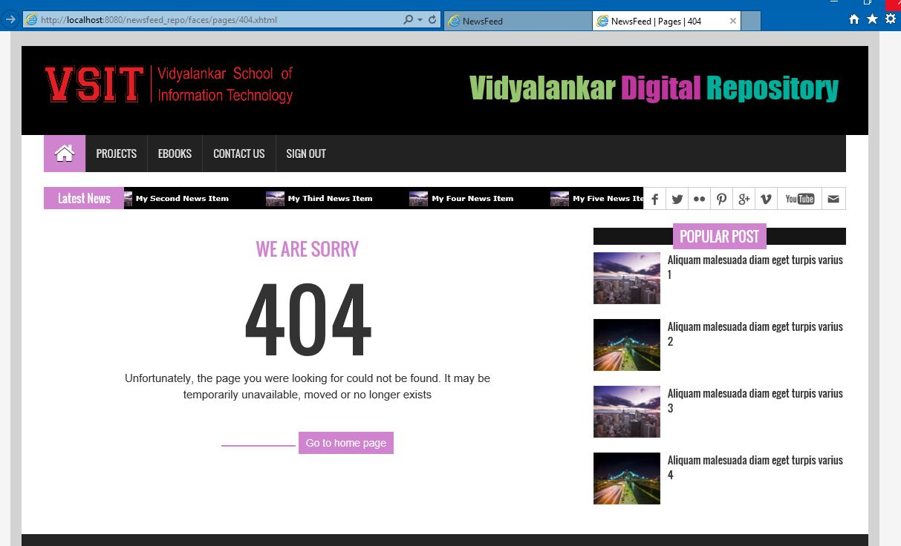

login.xhtml

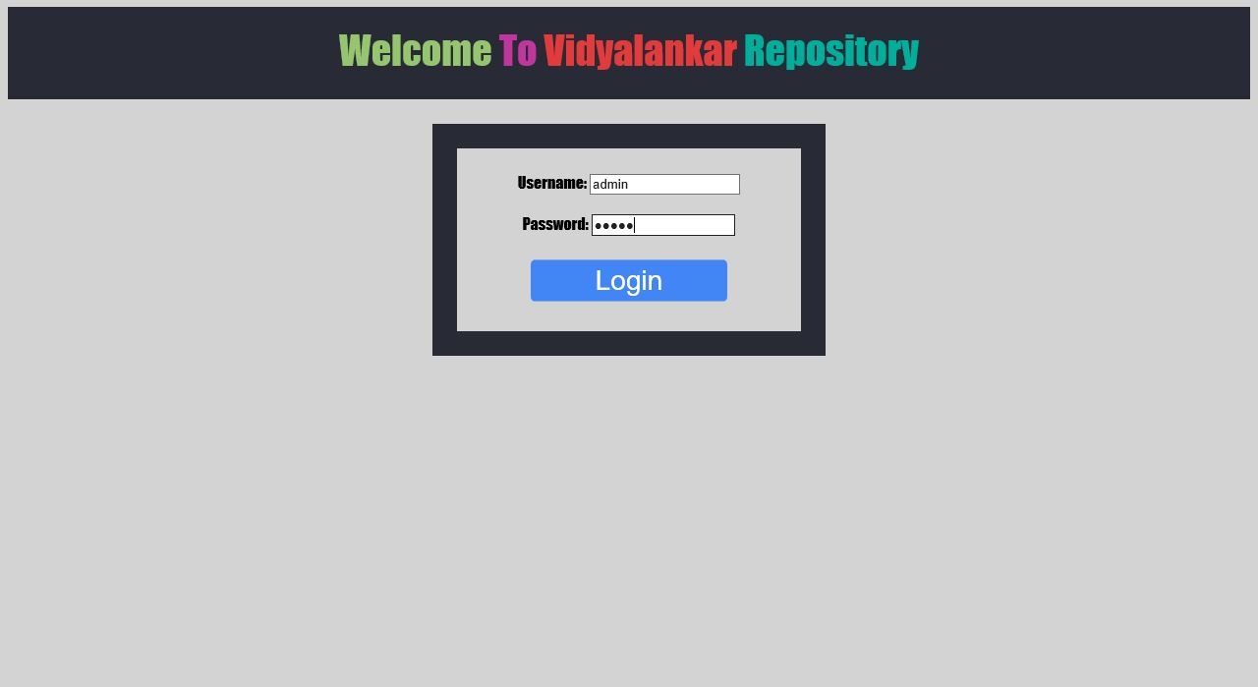

News_posting.xhtml

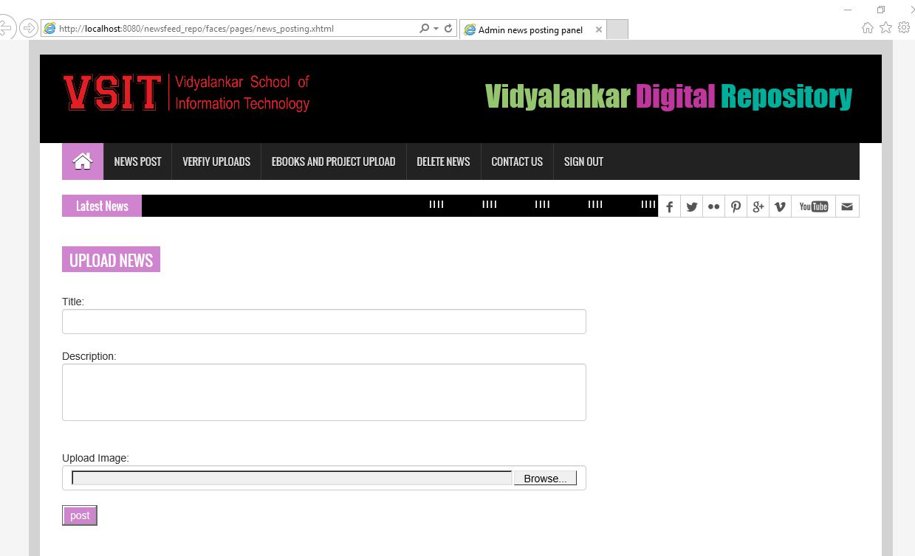

News_Delete.xhtml

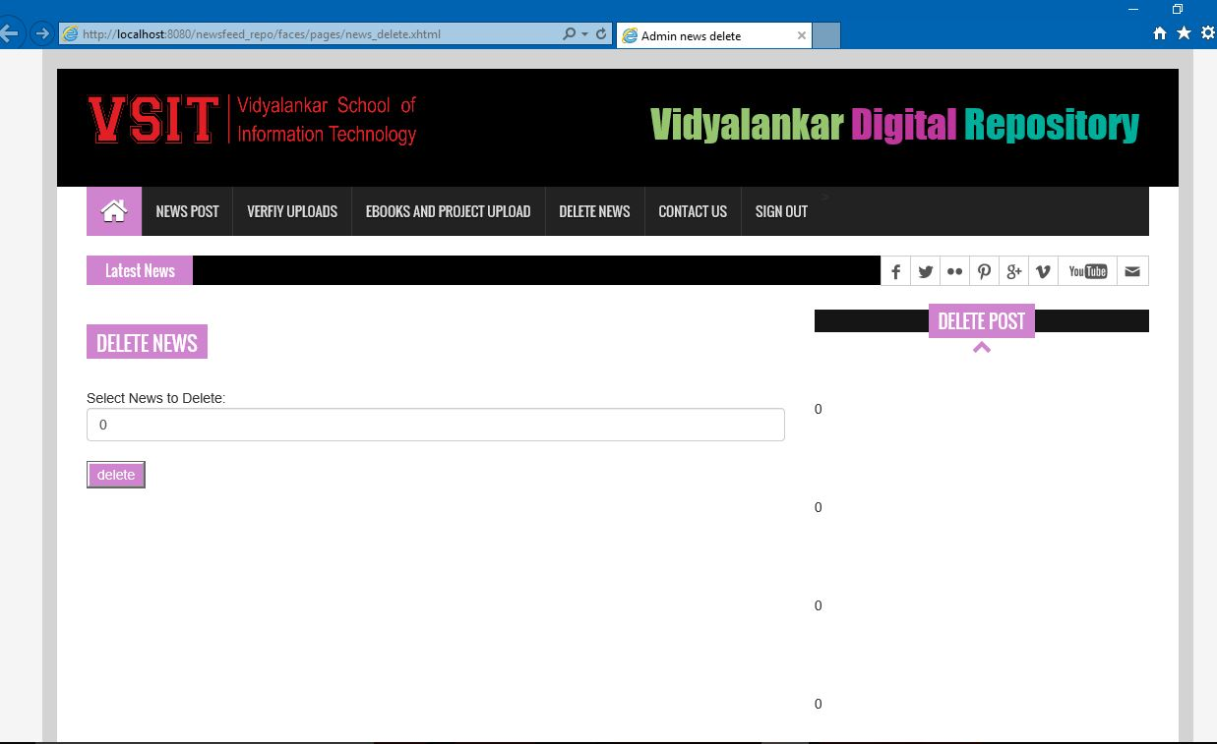

Single_page.xhtml

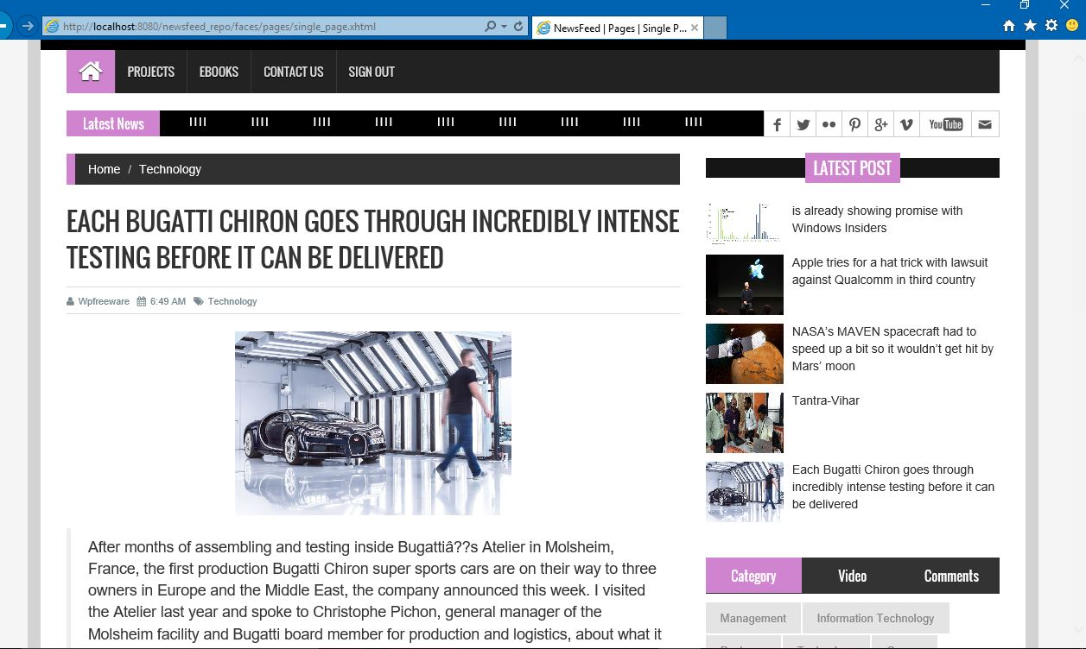

Bsc_repo.xhtml

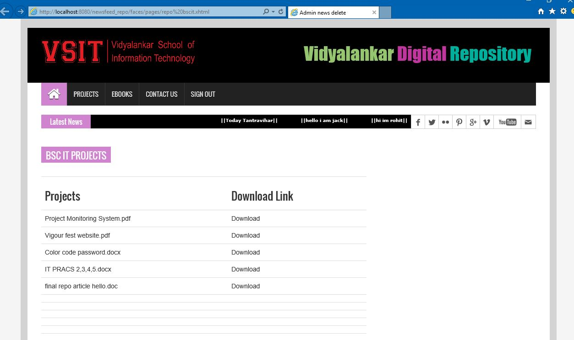

Index.xhtml

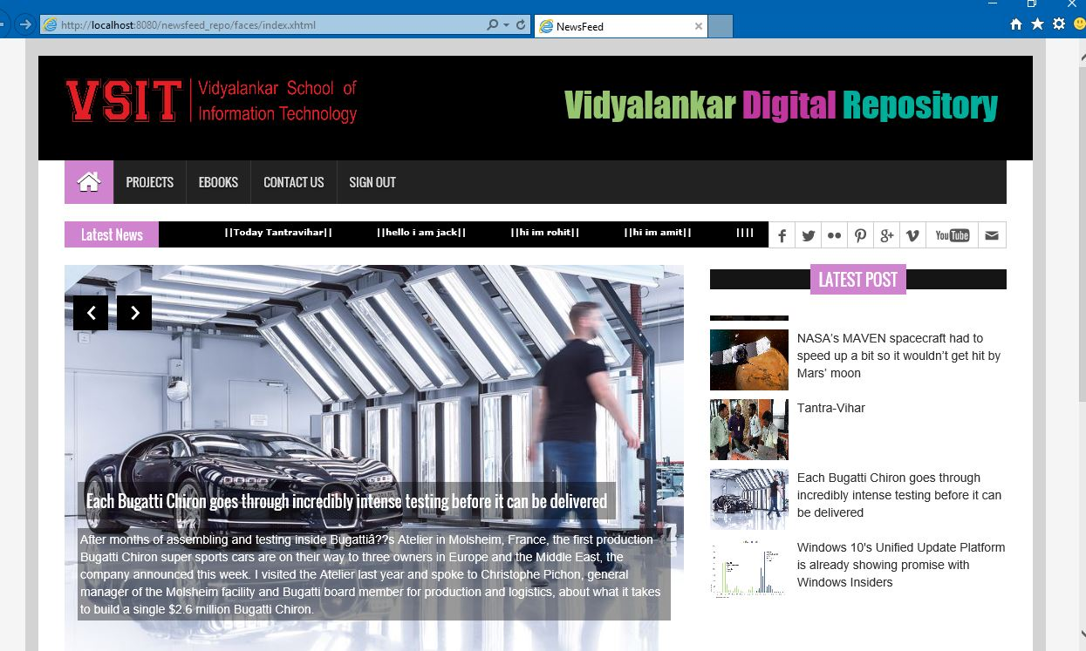

Contact.xhtml

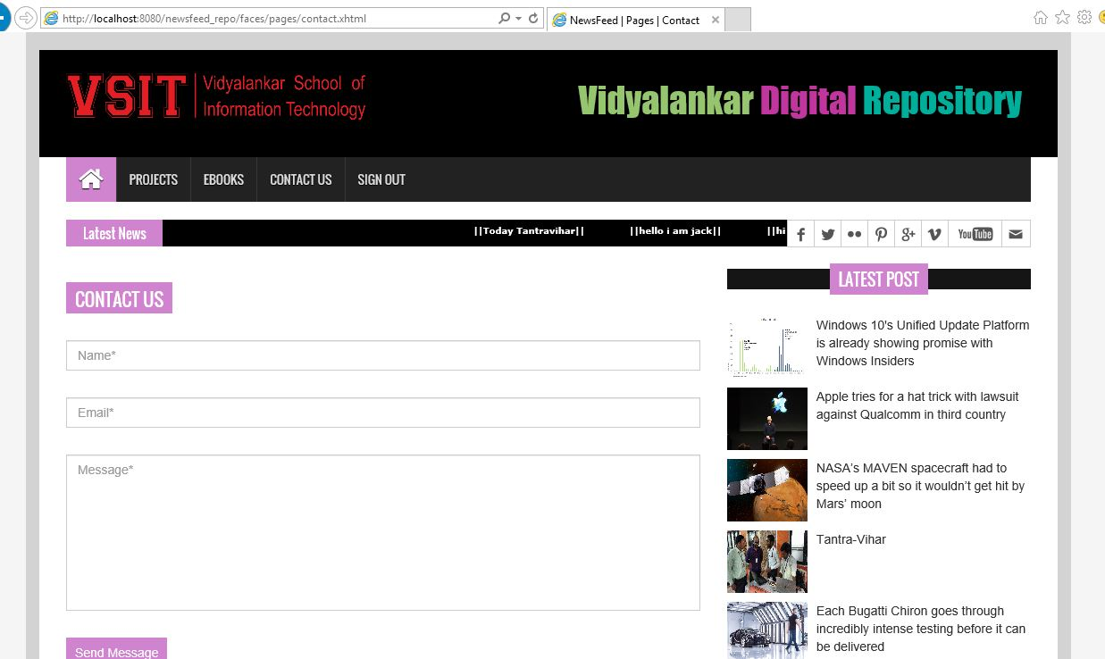

9. References/ Bibliography/ Website used

- Introduction to digital libraries, howdhury, G. and Chowdhury, S. (2002) Introduction to digital libraries. Facet Publishing. ISBN 1-85604-465-3
- ResourceCenter - A Digital Learning Object Repository with an Integrated Authoring Tool Set
- Digital data storage system with improved data migration
- https://www.cengage.co.in/
- Stanford Digital Repository https://library.stanford.edu/research/stanford-digital-repository
- DSpace: An Open Source Dynamic Digital Repository

